Perceptions and Evaluations of Weather-Based Energy Management among Galway Households: Exploring Adoption Factors.

Jean-Marie Temkeng Djoukang

A Thesis Submitted in Partial Fulfilment

of the requirements for the

Degree of

Master of Science in Data Analytics

May 2024

Supervisor: Kislay Raj

**Acknowledgements**

I'd like to thank the parents of students at Merlin College in Galway who took part in my survey. This research would not have been possible without their support. Their willingness to provide their time and expertise was important to this research. I'd also like to thank the members of my social network who participated, including those who received the survey via WhatsApp. I want to thank my SAP colleagues for their assistance and for taking the time to complete the survey.

Finally, I want to thank my wife and children for their continuous support throughout this research adventure. Their sympathy and patience throughout countless restless nights allowed me to spend the time and attention required to complete this project.

**Abstract**

This research investigates the perceptions and attitudes of Galway households towards weather-based energy management strategies and identifies the factors influencing their adoption. Through machine learning, this study employs machine learning models to analyze survey data, revealing a negative correlation between awareness about energy policies and the adoption of these strategies. This suggests that while awareness is important, it does not necessarily lead to action, particularly in the context of complex and potentially costly initiatives like energy management. The evaluation of models done at each training run provide clear understanding of these models performances. This study finds a positive correlation between income and the adoption of weather-based energy management strategies, indicating the significant role of financial resources in the decision to adopt such strategies. The machine learning models, while not directly measuring perception, provide valuable insights into the factors influencing attitudes towards weather-based energy management. These include household size, financial challenges, income level, provider information rating, and weekly consumption checks. However, the study also reveals several limitations, including data limitations, model generalizability, and indirect measurement of perception. These limitations highlight the need for further research to directly assess public perceptions and attitudes, refine feature engineering techniques, explore alternative machine learning models, and develop effective interventions promoting weather-based energy management practices. The results highlight how crucial public awareness is, financial resources, and other socio-economic factors in influencing attitudes towards the adoption of these strategies. This study provides a useful beginning point for assessing public perceptions and developing more effective strategies for promoting the adoption of weather-based energy management practices in Galway and beyond.

GitHub: <https://github.com/jmdjoukang/Capstone>

Contents

1. Introduction 1

1.1 Background 1

1.2 Research Objectives 1

1.3 Outline of the Thesis 2

2. Literature Review 2

2.1 Existing Studies on Weather-Based Energy Management in Residential Settings 2

2.2 Public Perception Research on Smart Grid Technologies 4

2.3 Factors Affecting Household Technology Adoption 6

2.4 Studies on Household Energy Management in Ireland 8

2.5 Conclusion 9

3. Methodology 10

3.1 Data Collection 10

3.2 Data Analysis 12

3.3 Sentiment Analysis 13

3.4 Word Cloud 13

3.5 Model Evaluation 13

3.6 Limitations and Future Research 14

4. Results 14

4.1 Quantitative data 14

4.1.1 Survey Demographics 14

4.1.2 Public Awareness of Weather-Based Energy Management 15

4.1.3 Perceived Benefits and Drawbacks 34

4.1.4 Factors Influencing Adoption Intention 34

4.2 Qualitative data 34

4.2.1 Themes Related to Public Perception 34

4.2.2 Themes Related to Adoption Factors 36

4.3 Conclusion 36

5. Discussion 37

5.1 Key Findings and Linkages to Existing Research 37

5.2 Understanding Public Perception in Galway 42

5.3 Factors Influencing Adoption in the Galway Context 44

5.4 Limitations of the Study and Future Research Directions 48

6. Conclusion 49

7. References 50

**Abbreviations**

NLP: Natural Language Processing  
F1: F1 Score  
MSE: Mean Squared Error  
EC: European Commission  
KNN : K Nearest Neighbour  
EDA : Exploratory data Analysis  
SVM : Support Vector Machines  
AUC : Area Under The Curve  
RFC: Random Forest Classifier  
ROC : Receiver Operating Characteristics  
GridSearchCV: Grid Search Cross Validation  
Met Eireann : The Irish Meteorological Service

**Figures:**

Figure 2.3 1: Attitudes and behaviours towards new technology 7

Figure 2.3 2:Prevalence of poor health in the energy versus non-energy poor population in 32 countries(Thomson et al, 2017) 8

Figure 2.3 3: awareness about energy policies 9

Figure 2.3 4: Pie chart of weather conditions most affecting 11

Figure 2.3 5: Pie chart of appliances using the most electricity 11

Figure 2.3 6: Pie chart of peak consumption times 12

Figure 2.3 7: Survey Columns 14

Figure 2.3 8: counts of each weather-based energy management strategy adoption 15

Figure 2.3 9: Adoption trend for income vs attitude 16

Figure 2.3 10: Load Clean Data, Separate Features 17

Figure 2.3 11: Linear regression MSE, R-Square 18

Figure 2.3 12: Logistic Regression Model 20

Figure 2.3 13: results with the original labels 20

Figure 2.3 14: Imported libraries 23

Figure 2.3 15: Code Snippet printing DataFrame shape 25

Figure 2.3 16: Random Forest Classification Model performance 26

Figure 2.3 17: Fitting the grid search to the data 27

Figure 2.3 18: Matrix of scatter plots 33

Figure 2.3 19: Correlation heatmap 33

Figure 2.3 20: code snippet improvement model print out after Hyperparameter 34

Figure 2.3 21: Model Evaluation after Hyperparameter Tuning Output 34

Figure 2.3 22: repeated features names 35

Figure 2.3 23: Word Cloud 35

Figure 2.3 24: Frequency of Themes Plot 36

Figure 2.3 25: Features importance in the model 40

Figure 2.3 26: relationships between occupation and other variables 43

Figure 2.3 27: relationships between income and other variables 43

Figure 2.3 28: relationships between monitoring and other variables 43

Figure 2.3 29: relationships between provider info rating and other variables 44

Figure 2.3 30: relationships between checking consumption and other variables 44

Figure 2.3 31: relationships between awareness about energy policies and other variables 44

Figure 2.3 32: relationships between weather effect on electricity and other variables 44

Figure 2.3 33: Correlation matrix 45

**Tables:**

Table 2.4 1: Frequency of Weather Conditions Affecting Energy Use 5

Table 2.4 2: Descriptive Statistics by Household Size 6

Table 2.4 3 : Frequency of Responses for Awareness about Energy Policies 8

Table 2.4 4: Descriptive Statistics of Awareness Level 9

Table 2.4 5: Descriptive Statistics household size 15

Table 2.4 6: Awareness about energy policies 15

Table 2.4 7: Classification report DT model 16

Table 2.4 8: adoption of weather-based energy management strategies 19

Table 2.4 9: Logistic regression model training 21

Table 2.4 10:model evaluation ROC AUC score 21

Table 2.4 11: Confusion matrix 21

Table 2.4 12: logistic regression model Results 22

Table 2.4 13: Random forest classification report before tuning 23

Table 2.4 14: SVM classification report 23

Table 2.4 15: KNN Classification report 24

Table 2.4 16: Imbalanced data handling classification report 24

Table 2.4 17: Original Data Frame and After encoding 25

Table 2.4 18: Table of Feature Importance Random Forest 41

Table 2.4 19: Summary Table of Model Results 46

Table 2.4 20: Factors Influencing Adoption 47

Table 2.4 21: Factors Influencing Perception and Adoption 48

# Introduction

## Background

Energy management is a major challenge for households globally, and weather-based energy management offers a potential answer. This strategy entails using meteorological data to optimize energy consumption, which could result in significant cost savings and environmental benefits. management is a crucial concern for households worldwide, and weather-based energy management presents a potential solution. This method involves utilizing weather data to optimize energy consumption, which could lead to substantial cost savings and environmental advantages. For households in Galway, this subject is especially pertinent. [Met Eireann], the Irish Meteorological Service, describes Galway's climate as having moderate winters and cool summers. This specific climate creates new opportunities and problems for energy management. This research intends to explore into these difficulties. Specifically, it seeks to answer the following questions: How do Galway households perceive and evaluate weather-based energy management? And what factors contribute to their attitudes towards adopting such strategies? By tackling these issues, the study intends to offer insightful advice to Galway homes that want to maximize their energy consumption and make a positive impact on a more sustainable future.

## Research Objectives

The aims of this research if to use machine learning technics to explore and evaluate the perception and the adoption of the government weather-based energy management strategies among Galway households. Thus, the research objectives are:

* To determine the variables that affect Galway families' perceptions of the acceptability of weather-based energy management techniques: In addition, the survey will contain questions aimed at identifying potential influencing factors for attitudes toward weather-based energy management. These could include things like earlier energy management experiences, economic and demographic conditions, and attitudes toward the environment. The influence of these factors will be analyzed using regression analysis and other appropriate statistical techniques
* To investigate how Galway households see and assess weather-based energy management: A survey will be given to a sample of Galway households that is representative. Inquiries concerning their present energy management procedures, knowledge of and comprehension of weather-based energy management, and assessments of its viability and efficacy will all be included in the survey. In order to find patterns and trends, the survey data will be examined using machine learning and descriptive statistics.
* To look into how national and local policy influence attitudes and the adoption of weather-based energy management techniques: This will require meeting with decision-makers and other stakeholders, as well as researching relevant national and local policies. The survey results and expert interviews will be examined to determine the effectiveness of these policies.
* In light of Galway's unique climate, to understand the potential benefits and challenges of weather-based energy management: A component of this will involve a review of the scientific literature on weather-based energy management, with a focus on studies conducted in climates similar to Galway. To supplement this assessment, experts in the domains of climate science and energy management will be interviewed.

## Outline of the Thesis

The thesis' remaining sections are arranged as follows: In Chapter 2, a thorough assessment of the literature is presented, covering studies that have already been done on weather-based energy management in homes, studies on household energy management in Ireland, and public opinion research on smart grid technologies. The methodology used in this study is covered in Chapter 3, along with word clouds, sentiment analysis, data collection and analysis techniques, model evaluation, and a discussion of the study's shortcomings and future research goals. Chapter 4 presents the results of the study, including survey demographics, public awareness of weather-based energy management, perceived benefits and drawbacks, factors influencing adoption intention, and single models in short-term demand forecasting. Chapter 5 discusses the key findings and their linkages to existing research, understanding public perception in Galway, factors influencing adoption in the Galway context, and limitations of the study and future research directions. Finally, Chapter 6 concludes the thesis, summarizing the main findings and their implications for Galway households and future research in weather-based energy management. The references used throughout the thesis are listed at the end.

# Literature Review

This thesis will analyze a variety of studies and research on weather-based energy management, with a focus on literature evaluation. A complete understanding of the issue will necessitate a review of research conducted in different residential settings, not just Galway. Therefore, this study will also look at the public's perception of smart grid technologies, as well as the factors that influence their adoption in homes. This section will review numerous studies on household energy management in Ireland in order to help set the stage for the study topic. This comprehensive review will help to identify gaps in the existing literature and provide a solid foundation for the research on Galway households' perception and evaluation of weather-based energy management.

## Existing Studies on Weather-Based Energy Management in Residential Settings

While this study directly examines public perception of government policies on weather-based energy management, it's valuable to consider existing research on the topic. Studies have explored public understanding and acceptance of weather-dependent energy management strategies. In some countries Scientists and building energy experts continue to struggle to find the best formula for the renewable energy (Rahmani, et al., 2022). These studies offer insights into factors influencing public perception, such as concerns about data privacy, potential disruptions, and cost implications. Understanding these factors becomes even more crucial as weather-based energy management becomes increasingly integrated with smart grid technologies. Studies on consumer engagement methods for attracting residential consumers, especially low-income ones, remain limited (Schwartz, 2017).By drawing on the findings from this survey and existing research, policymakers can develop strategies to effectively communicate the benefits and address potential concerns surrounding weather-based energy management policies. As a result, the switch to a more weather-responsive and efficient energy system may go more smoothly.

The growing need for sustainable energy solutions has led to a resurgence of interest in weather-based energy management in recent years. -It has been observed that, the intermittent nature of renewable energy sources, such as rooftop solar and wind power, poses a challenge to grid stability - (Mifeng Ren a, 2022). Studies reveals that Sustainable Energy Development Strategies typically involve three major technological changes: energy savings on the demand side, improvement in the energy production and replacement of fossil fuel (Lund, 2007).The potential of weather-based energy sources, such as wind and solar power, in residential settings have been explore by (Naik, et al., 2024). These studies have highlighted the potential benefits of these energy sources, including reduced energy costs and lower carbon emissions. They do, however, also highlight some of the difficulties in adopting them, including the start-up costs and weather fluctuation.

The Irish government set itself the goal of increasing energy efficiency by 20% nationally by the year 2020. Given the public sector's capacity for leadership, a more demanding goal of 33% improvement was established for it. This is the reason why the public sector has advanced significantly since then, with a 27% increase in energy efficiency (Department of the Environment, Climate and Communications, 2020).

**Impact of Rainfall on Electricity Consumption**

The impact of rainfall on electricity consumption has been investigated as a meteorological variable. The relationship between rainfall and energy usage is a multifaceted phenomenon, as opposed to temperature, as it is contingent upon variables such as the quantity and duration of precipitation (Zhou, 2019). (Simaremare, 2021)conducted a study to investigate the relationship between rainfall and electricity consumption. Despite the absence of reliable data on household composition, electricity consumption for the middle group is higher compared to the electricity consumption for the younger age group. It has been demonstrated that households with a higher number of occupants consume more energy especially when the occupants stay home due to the rainfall. Studies revealed that a rise of 1 millimetre in rainfall resulted in a decrease of 0.1 kWh in power usage. Nevertheless, alternative research has confirmed a favourable correlation between precipitation and electrical power usage, this can be demonstrated by using the data gathered to infer the relationship between electricity use and occupant characteristics.

(Zhou, 2019) investigation of the relationship between rainfall and electricity consumption shows a positive correlation between the two variables contradicting the previous study where a negative correlation was found. (Valor, 2002) demonstrate that a rise of one millimetre in rainfall resulted in a corresponding increase of 0.033 kilowatt-hours in electricity usage. The observed phenomenon was ascribed to the correlation between precipitation and the heightened need for temperature regulation mechanisms (Eskeland, 2010). The impact of rainfall on electricity consumption in Galway has been subject to limited research. EPA (2022) revealed that the rise in precipitation caused by climate change could result in a surge in demand for electricity.

(Reiner & Kang, 2022) conducted a study examining the correlation between precipitation and electricity usage in Ireland, utilizing daily data. The research revealed a positive correlation between precipitation and electrical energy usage, albeit solely during winter. (Liu, 2021) indicate that a rise of one millimetre in winter precipitation resulted in a corresponding increase of 0.4 kilowatt-hours in electricity usage. (Ozoh, et al., 2014) suggested that the upsurge in precipitation during the winter season led to a surge in the need for heating systems that rely on electricity.

Nonetheless, the impact of precipitation on electrical usage throughout the summer season did not demonstrate statistical significance, as the requirement for electrical power to operate cooling mechanisms was not substantial (Zachariadis & Pashourtidou, 2007). The correlation between precipitation and electricity consumption can be attributed to rainfall's effect on hydroelectric energy production. Hydroelectric power is a sustainable energy source that harnesses the kinetic energy of water in motion to produce electrical power—elevated precipitation results in augmented water levels within rivers and reservoirs, amplifying hydroelectricity production capacity (Moral-Carcedo & Vicéns-Otero, 2005). According to (Razavi, et al., 2019), a notable proportion of Ireland's renewable energy production is attributed to hydroelectric power. Consequently, augmented precipitation can yield a favourable effect on the provision of electricity, potentially affecting electricity demand.  
  
 **Seasonal Variations in Electricity Consumption in Galway**

Twenty-three percent of electricity usage in 2021 came from large energy users. Because of the potential implications for energy policy and management, studies, academics have focused on the study of seasonal fluctuations in Galway, Ireland's electricity usage. several research have observed that there is a pattern indicating that Galway's electricity consumption is higher in the winter than it is in the summer (Thornton, et al., 2017). Winter's higher electricity consumption is primarily due to the increased need for heating. According to - (Foley & Leahy, 2012) research, Space heating was the largest contributor to Ireland's electricity usage. Nearly all research indicates that, in Galway, the temperature drops significantly during the winter, increasing the demand for indoor heating. Electric heating systems, which need a large quantity of electrical energy to operate, meet this demand. According to Gavin (Zhang, et al., 2022). Moreover, Galway's ancient buildings with inadequate insulation tend to be more popular for the usage of electric heating devices and other heating techniques. The utilization of electric lighting is another contributing factor to Galway's electricity consumption variations during different seasons. The reduced daylight hours experienced in winter necessitate prolonged usage of artificial lighting, leading to a surge in electricity consumption (Conevska & Urpelainen, 2020). Electric lighting is commonly utilized in commercial and industrial structures, which exhibit a higher demand for electricity than in residential buildings. Weather patterns significantly influence the seasonal fluctuation of electricity consumption in Galway. (S.Firth, et al., 2008) conducted a study that revealed that temperature, humidity, and wind speed were notable indicators of electricity demand in Ireland.

## Public Perception Research on Smart Grid Technologies

Past studies revealed that adoption of new technology, particularly smart grid technologies, is heavily influenced by public perception. Early research relied on broad summaries of power grid data to create operational plans. They can leverage this knowledge to promote and enhance demand-side efficiency and sustainability. This can involve optimizing grid operations, implementing targeted demand-response programs, and promoting energy-saving measures (Kang, 2020). They can develop more effective policies to guide consumers towards sustainable living practices. This can help achieve decarbonization goals, reduce energy insecurity, and potentially alleviate energy poverty. Several studies have explored public attitudes towards smart grid technologies. While these studies generally reveal a positive perception, concerns about privacy and security also exist. Addressing these concerns is crucial for promoting widespread adoption of these technologies. As grid modernization progresses, advanced sensor data and communication technologies are being integrated to create a data-driven electricity network with enhanced efficiency and security (European Commision, 2013).

While opinions vary, the potential of smart meters to influence customer behavior is supported by models of behavior change. These models highlight the importance of clear information. By providing transparent consumption data, smart meters reduce information asymmetry – the gap between what the utility knows and what the customer knows. This empowers consumers to assess the impact of their energy usage more accurately, potentially leading to more informed decisions and behavior changes (Kang, 2020).

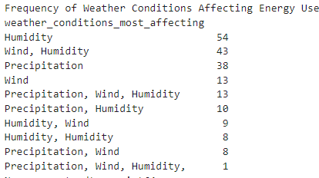

Table 2.4 : Frequency of Weather Conditions Affecting Energy Use

(Table 2.4 1) highlights the weather conditions that households in Galway believe have the most impact on their energy consumption. The data reveals a range of factors, with 'humidity' mentioned most often (54 respondents). Next in order of importance are 'Wind, humidity' (43 respondents) and 'Precipitation' (38 respondents). Paradoxically, a few homes stated that more than one weather factor affected how much energy they used, including 'Rainfall, Wind, Humidity' (13 respondents) and 'Rainfall, Humidity' (10 respondents).

These findings suggest that households in Galway take different weather elements into account when considering their energy consumption. In particular, the presence of multiple weather options chosen by some respondents highlights the potential for a complex interaction between different factors influencing energy consumption.

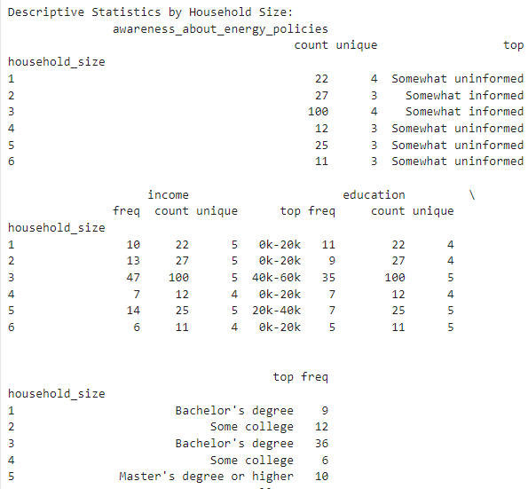

Table 2.4 : Descriptive Statistics by Household Size

The descriptive statistics in (Table 2.4 2) offer a rich dataset for understanding how public awareness of government energy policies varies among different household sizes and socioeconomic factors in Galway. By analyzing the distribution of responses across these categories, we can identify potential trends and inform targeted communication efforts. The table shows data for households ranging in size from 1 to 6 occupants (indicated by "household size"). The number of respondents varies across these categories, with the highest number (100) belonging to households with 3 occupants. The (Awareness about energy policies) captures the level of awareness for each household. "Somewhat uninformed" is the most common response across all household sizes, suggesting a general need for improved communication.

However, there are variations:

* Smaller households (1 and 4 occupants) consistently report "Somewhat uninformed" as the most frequent response.
* Medium-sized households (2, 5, and 6 occupants) show some variation. While "Somewhat informed" is the top response for household sizes 2 and 5, "Somewhat uninformed" remains dominant for household size 6. Then "Somewhat informed" is the most common response for household size 3, which is interesting and points to a possible relationship between household size and awareness levels in this particular situation.

## Factors Affecting Household Technology Adoption

Adoption of new technologies in a home can be influenced by a number of factors. Research revealed a strong social influence on technology adoption. Individuals aware of neighbours or peers who had already adopted the technology were more likely to follow suit themselves. Interestingly, only 11% of respondents identified as "innovators," meaning they typically try new technologies first. The majority (43%) fell into the "early adopter" category, expressing willingness to try new technologies but waiting until someone they know uses it first. This cautious approach is further reflected by the 26% who categorized themselves as "late adopters," preferring to wait until most people they know have adopted the technology (Ryan, 2024). Other identified factors such as income, awareness of energy policies, and attitudes towards sustainability are key determinants of technology adoption. This research suggests that strategies to promote the adoption of weather-based energy management strategies should take these factors into account.

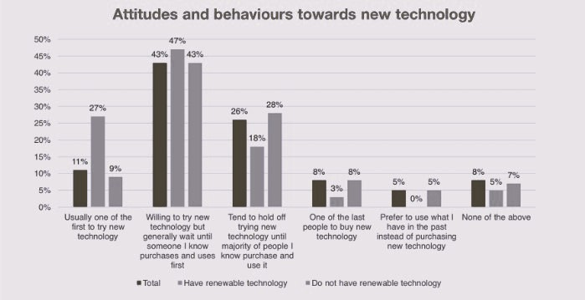

Figure 2.3 : Attitudes and behaviours towards new technology

As mentioned in chapter 2.2, energy poverty is a big concern in the city. A household is considered energy poor if it cannot afford to maintain a comfortable and safe living environment with adequate heating and essential energy services. This struggle, also known as "fuel poverty," presents a significant and complex challenge with social, economic, and policy dimensions (Lawlor & Visser, 2022). While income and poverty surveys offer valuable insights, they often lack crucial details needed to accurately assess energy poverty. These surveys typically don't capture how much a household spends on energy bills is essential to evaluate their energy affordability struggles. General expenditure surveys might not provide the granular level of detail needed to pinpoint energy-related expenses within a household's budget (A & REAÑOS, 2021). This lack of household-level energy data represents a significant challenge in pinpointing and addressing energy poverty effectively.  
  
Ireland faces a unique set of challenges regarding energy poverty. The shift towards renewable energy sources and increased reliance on imports raise concerns about affordability for vulnerable populations. Additionally, the potential rise of air survey ution from wood-based fuels and the needs of an aging population demand consideration. Careful policy design that addresses these factors is crucial to ensure a just transition to a sustainable energy future for all Irish citizens (Lawlor & Visser, 2022).

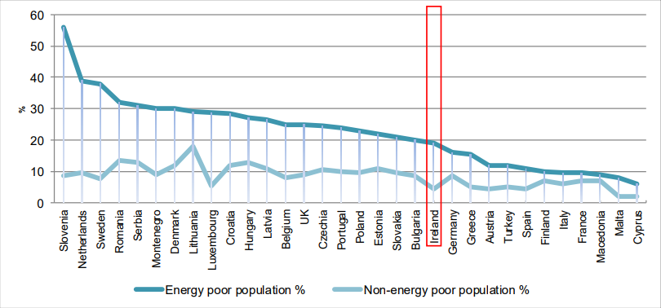

Figure 2.3 :Prevalence of poor health in the energy versus non-energy poor population in 32 countries(Thomson et al, 2017)

## Studies on Household Energy Management in Ireland

Research on energy efficiency in Irish homes, including (Sustainable Energy Authority of Ireland, 2022), have offered insightful explanations of the particular circumstances of our nation. According to the study, air conditioning, heating, water heating, ICT, automatic doors, lifts and escalators, and lighting are some of the building's electrical requirements. In addition, off-road electric cars, public lighting, and water and sanitation services also require electricity. Over 40% of energy consumption and 36% of CO2 emissions in the EU are attributed to buildings, making them the single largest energy consumer in Europe - (European Commision, n.d.). These studies highlight the potential of weather-based energy sources in Ireland, but they also highlight the barriers to their adoption, such as the need for public-awareness campaigns and government support. When the Irish government agreed in July 2022 to set aside extra money to encourage the development of 5,500 MW of solar generation and 7,000 MW of offshore wind-generating by 2030, it demonstrated a major commitment to renewable energy. The goal of this project is to meet Ireland's increasing need for renewable energy capacity and quicken the nation's overall progress toward lowering greenhouse gas emissions (Sustainable Energy Authority of Ireland, 2022).

The government of Ireland persisted in placing a high priority on long-term environmental objectives in addition to providing consumers with urgent relief during an energy crisis. Measures like Electricity Credits and business support schemes provided direct relief to homes and businesses. Encouragingly, renewable energy development remained on track, with record-breaking connections in 2022 and the successful launch of Ireland's first offshore wind auction in 2023. This demonstrates Ireland's commitment to navigating the current crisis while building a sustainable energy future.

While a significant portion of Galway households 91 reported feeling "somewhat uninformed" about government energy management strategies according to (Table 2.4 3), it's important to take a closer look at the numbers. An additional 78 households identified as "somewhat informed," suggesting some level of public awareness. However, only 18 households felt "very informed," highlighting a potential gap in understanding these strategies.

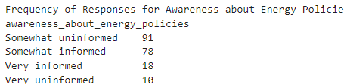

Table 2.4 : Frequency of Responses for Awareness about Energy Policies

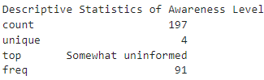

Table 2.4 : Descriptive Statistics of Awareness Level

By looking at (Table 2.4 4), you can gain valuable insights into the public's awareness of energy policies in Galway and inform strategies for improving communication and knowledge dissemination. The (Table 2.4 4) summarizes the awareness levels of energy policies among Galway households. Analyzing this data helps us understand the public's knowledge base regarding government initiatives.

As discussed in 2.2, Although public acceptance of smart grids is essential to their success, they have the potential to increase energy security, sustainability, and efficiency. Descriptive data in the study indicate a low level of public awareness regarding Galway's energy policies (Table 2.4 4), indicates a possible lack of understanding about smart grid technologies. This localized survey offers valuable insights into public perception within this specific context.

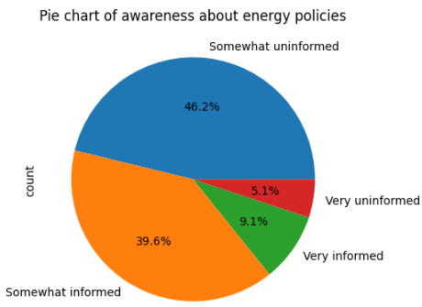

Figure 2.3 : awareness about energy policies

The (Figure 2.3 3) suggests that a significant number of people are either somewhat uninformed or very uninformed about energy policies. This lack of awareness could potentially impact the public's perception and acceptance energy policies as well as of 2.2 as these technologies are closely tied to energy policies. For example, smart grids are frequently touted as a way to put more effective and sustainable energy regulations into place. The public may not completely comprehend the advantages of smart grids, though, and they may even be sceptical of them if they are not well-informed on these policies. This might make it more difficult for smart grid technology to be adopted and used.

As a result, raising public knowledge and comprehension of energy regulations is essential to advancing smart grid technology. To ensure that the public is not only aware of energy policies but also knows how these policies and the related technology, like smart grids, may benefit them and society at large, this could involve educational campaigns, public consultations, and other types of involvement.

## Conclusion

The strengths of weather-based energy management in residential settings, the role that public opinion plays in new technology acceptance, the variables that affect household technology adoption, and the unique circumstances of Ireland have all been brought to light by the literature review. By investigating Galway households' opinions regarding weather-based energy management techniques, this study seeks to expand on previously published findings. There remains a lack of knowledge on the use of weather-based energy management and household technology uptake in the particular setting of Galway, Ireland, despite the abundance of research on these topics. Few studies have been conducted that look into these concerns locally; most of the ones that have been done so have a global or national scope. In order to close this disparity, this study will concentrate on Galway families' opinions and assessments of weather-based energy management techniques. More research is required to understand how these elements interact and influence one another, even if the literature now in publication offers insightful information about the factors driving home technology adoption. By examining the intricate interactions between these variables in the context of Galway homes, this study will advance our understanding of the subject.

Last but not least, the corpus of prior research highlights the critical role that public opinion plays in new technologies adoption. Additional research is required to resolve any problems and clearly convey the benefits of these technologies. Our knowledge of the topic will be expanded by this research, which will look at Galway families' opinions on weather-based energy management strategies and identify effective communication strategies.

# Methodology

## Data Collection

An online survey was sent to Galway households in order to gather data for this study. The purpose of the survey was to collect data on respondents' knowledge and comprehension of weather-based energy management techniques, their opinions of these techniques, and the variables influencing their choice to implement these techniques. The study additionally gathered demographic data, such as household size, income bracket, and profession, to facilitate a more intricate examination of the variables impacting perspectives on weather-based energy management. The survey also collected data on the household's perception of the effect of weather conditions on their electricity consumption (Figure 2.3 1), the specific weather conditions that most affect their consumption, and the challenges they face in adopting weather-based energy management strategies.

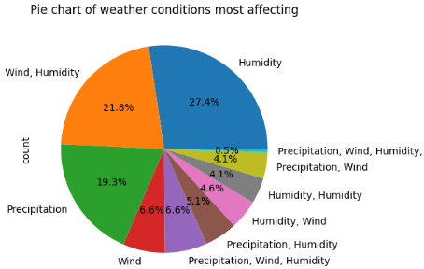

Figure 2.3 : Pie chart of weather conditions most affecting

Further information was gathered regarding the methods used by the household to keep an eye on and verify their energy usage, the appliances that draw the most power from their residences (Figure 2.3 5) and the times when they self-report having their highest electricity usage (Figure 2.3 6). Demographic data like the respondent's age, income, occupation, and level of education was also collected through the survey. 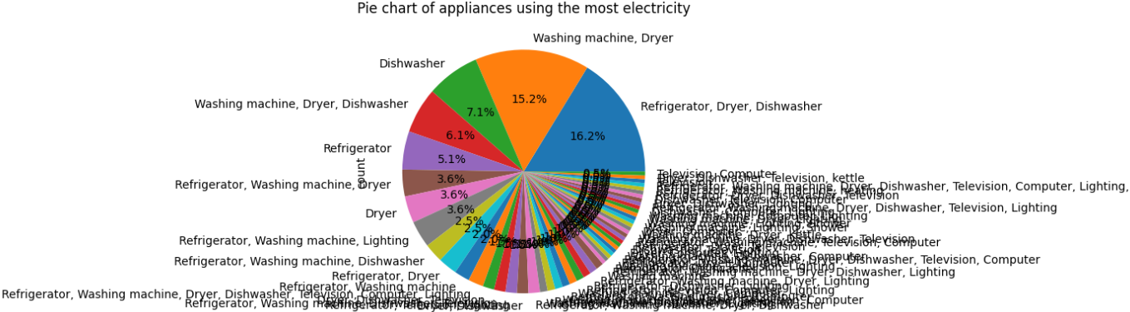

Figure 2.3 : Pie chart of appliances using the most electricity

After that, the answers were numerically coded to make statistical analysis easier. -For example, there were four categories for the level of understanding of energy policies: -"Very uninformed," "Somewhat uninformed," "Somewhat informed," and "Very informed." The same codes applied to self-reported peak consumption times: 'Saturday', 'weekend', 'holidays', 'Evening', 'Everyday', 'Sunday', 'Morning', 'Friday', 'Negative', 'Sundays', 'Every day', 'evening', and 'Monday'. 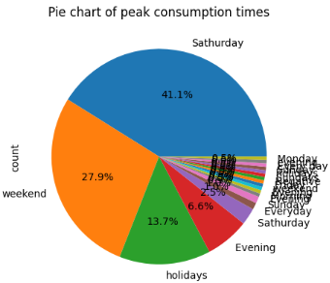

Figure 2.3 : Pie chart of peak consumption times

The information gathered offers a thorough picture of Galway families attitudes and behaviours with relation to weather-based energy management. This information will be utilized to address the research questions and advance knowledge of the variables influencing the implementation of these tactics. Furthermore, the government intent and interventions promoting weather-based energy management practices can be informed by this study.

## Data Analysis

The survey data was evaluated using a variety of machine learning methods, such as linear regression, decision trees, multinomial logistic regression, and Random Forest. These models were chosen for their capacity to handle massive datasets and predict outcomes using a collection of input factors. -The primary goal of machine learning research is to develop fast and efficient learning algorithms that provide data forecasts (Athmaja & Hanumanthappa, 2017).

The linear regression model was used to examine the relationship between awareness about energy policies and the adoption of weather-based energy management strategies. The decision tree model was used to explore the factors that contribute to attitudes towards adopting such strategies. The logistic regression and Random Forest models were used to identify the weather conditions that most affect energy usage.   
Recall, accuracy, precision, F1 score, and other relevant measures were used to assess each model's performance. The precision with which a model produces predictions or classifications on fresh, unidentified data is known as model performance in machine learning (hopsworks, 2020). Model performance is often measured using a test set, which compares predictions to actual outcomes. The feature importance of each model was also examined to identify the most influential factors in predicting attitudes towards weather-based energy management. The data analysis involved several steps. First, a correlation analysis was conducted to identify relationships between different variables. This analysis revealed a strong negative correlation between awareness about energy policies and the adoption of weather-based energy management strategies, and a positive correlation between income and the adoption of these strategies. Next, a parallel coordinates plot was created to visualize the high-dimensional data and further explore the relationships between variables. However, due to the complexity of the plot, it was difficult to draw definitive conclusions from this visualization alone. A parallel coordinate plot is a graphical method in which each observation or data point is represented as a line crossing a sequence of parallel axes that correspond to a certain variable or dimension. This format enables the investigation of correlations, trends, and variations that may be obscured in raw data (Jaspersoft, n.d.).

To further investigate the factors influencing the decision to adopt weather-based energy management strategies, a multinomial logistic regression was performed. This model is used to predict a nominal outcome variable with more than two categories that do not have a specific rank or order. This model is suitable for any number of categorical or continuous independent variables (National University Academic Success Center, 2024). This analysis allowed to control for the effects of other variables and determine the unique contribution of each factor to the decision to adopt the strategies. Then the Random forests which are a combination of tree predictors such that each tree depends on the values of a random vector sampled independently and with the same distribution for all trees in the forest. The generalization error for forests converges as to a limit as the number of trees in the forest becomes large (Adele Cutler, 2011).

## Sentiment Analysis

In addition to the quantitative analysis, a sentiment analysis was conducted on the responses to gain insights into the general attitude towards weather-based energy management among Galway households. The analysis yielded an average sentiment score of 0.015228426395939087, suggesting a marginally positive sentiment. This will elaborate 4

## Word Cloud

The word cloud represents the important themes explored in 3.3. The usage of words like "information," "government," "sustainable," "public," and "financial" reflects the public's need for more information, the government's perceived role, the relevance of sustainability, and the significance of financial considerations. While terminology like ‘sessions,' 'conferences,' 'grants,' 'construct,' and 'housing' appear, they may be less prevalent, indicating a secondary focus on specific implementation details rather than broader topics.

## Model Evaluation

Finally, the performance of the multinomial logistic regression model was evaluated using a confusion matrix and RFC (RandomForestClassifier). The evaluation results indicated that the model correctly classified 42.5% of the data points in the testing set. The poor performance of the multinomial logistic regression model clearly shows that there is a room of improvement, and several other models were tested with acceptable result, such as RFC model with approx.: 80% of accuracy , tune using hyperparameter GridSearchCV for even greater result of up and close to 90%

## Limitations and Future Research

While training a Logistic Regression model to predict the likelihood of a household adopting weather-based energy management strategies based on the challenges they face was one approach, which shows poor results, other models like Random Forests in other hands performs good while training the random forest algorithm with the selected processed features from the survey. For the correlation between features, SVM , KNN ,(GridSearchCV) were explored. Overall, the research provided valuable insights, it's important to note that correlation does not imply causation. The relationships identified in this study could be influenced by other factors not included in the dataset. Future research could involve a more in-depth analysis of the responses to identify common themes or points of discussion within the responses. This could provide valuable insights into the specific aspects of weather-based energy management that are viewed positively or negatively by Galway households.

# Results

## Quantitative data

### Survey Demographics

The survey, which was conducted with this broad community, included respondents of all ages, educational backgrounds, and economic levels. This variability allowed for a full understanding of Galway households' attitudes and perspectives on weather-based energy management policies. 197 Galway homes, representing a broad spectrum of ages, educational attainment, and economic levels, participated in the survey. With a standard deviation of 1.28 and an average household size of roughly 3.12, the survey's results show a moderate range in household sizes. There were six households in total, with one being the smallest. The median result showed that three people made up the majority of the households (50%) in this sample.

The wide range of family sizes and compositions allowed for a thorough knowledge of Galway households' attitudes and beliefs regarding weather-based energy management techniques. The questionnaire covered a wide range of topics, including the type of dwelling, attitudes toward energy use, knowledge of energy regulations, adoption of weather-based energy management techniques, difficulties encountered, tracking, and examining consumption patterns, the appliances that use the most electricity, self-reported peak consumption hours, provider information ratings, and extra remarks.

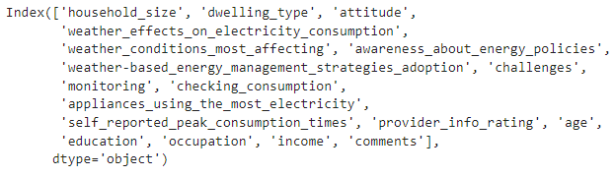

Figure 2.3 : Survey Columns

A knowledge of the attitudes and opinions regarding weather-based energy management solutions that is more inclusive, and representative was made possible by the respondents' wide demographic profile. It is because of this diversity that the survey's conclusions are applicable to a wide spectrum of Galway families.

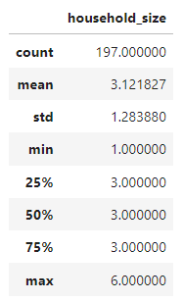

Table 2.4 : Descriptive Statistics household size

### Public Awareness of Weather-Based Energy Management

To check the public awareness of weather-based energy management, a regression model has been created, train and evaluated.

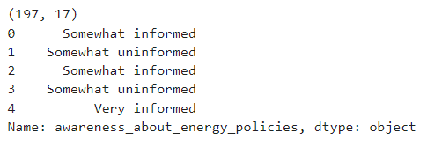

Table 2.4 : Awareness about energy policies

The data shape (197, 18) indicates that the dataset utilized in this research study has **197** observations and **18** variables. Separating the characteristics from the target variable was the first stage in the analytic process. This is important because it makes it possible to distinguish clearly between the outcome variable and the predictors, which makes the analysis more precise and effective.

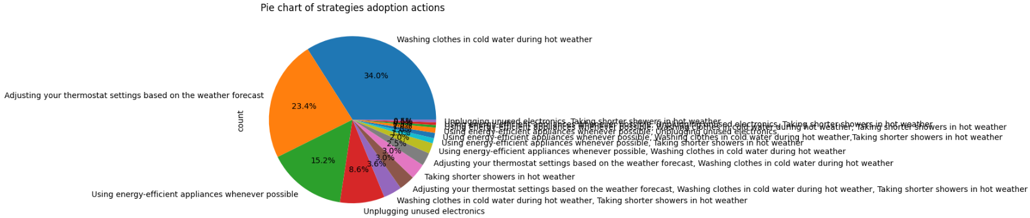

Figure 2.3 : counts of each weather-based energy management strategy adoption

The (Figure 2.3 8) shows that the most popular weather-based energy management strategy among Galway households is washing clothes in cold water during hot weather, followed by adjusting thermostat settings based on the weather forecast. This suggests that simple, low-cost strategies are more readily adopted. However, the use of energy-efficient appliances, despite their potential for significant energy savings, is less common. This could be due to the higher upfront cost of these appliances, indicating that cost is a major factor in households' adoption of energy management strategies.

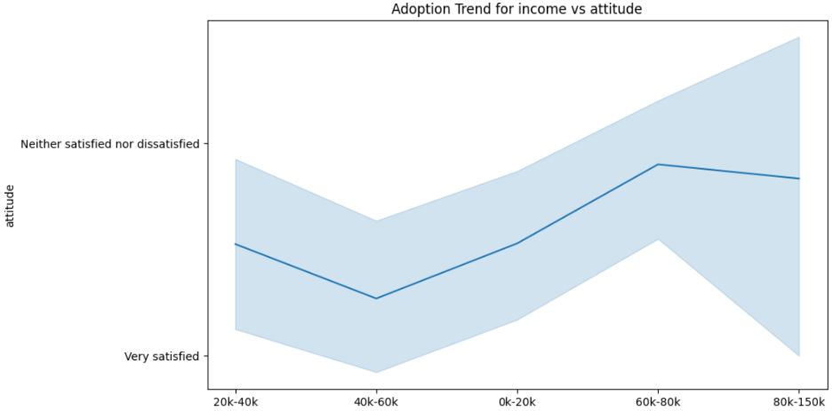

Figure 2.3 : Adoption trend for income vs attitude

The (Figure 2.3 9) shows the adaption trend for income vs attitude, it can be observed that the adoption trend of weather-based energy management strategies does not seem to be significantly influenced by the income level of the households. The attitude towards these strategies appears to be generally positive across different income brackets. However, it is important to note that the data shows a mix of satisfaction levels towards dwelling type, which may indirectly influence the adoption of these strategies. Further research may be needed to explore the potential correlations between income, attitude, and the adoption of weather-based energy management strategies.

* **Decision Tree Classifier model**

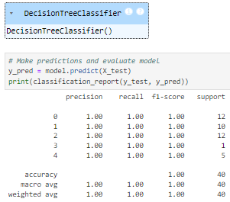

Table 2.4 : Classification report DT model

A perfect accuracy score (1.00) on a small dataset (n=40) is achieved by the decision tree model. However, this result necessitates a more careful interpretation. Reasons will be discussed in the next chapter 5

* **Linear Regression Model**

Taking care of the target variable came next. As it guarantees that the target variable is accurately described and prepared for use in the model, this procedure is crucial to data analysis. Prior to starting the analysis, it entails examining the target variable for any flaws or inconsistencies and fixing them. Coding the category features was another aspect of the investigation. Variables without an order or priority that can be categorized into many groups are known as categorical characteristics. By converting these categories into a format that the machine learning algorithms can understand better, encoding these attributes enables a more accurate analysis.

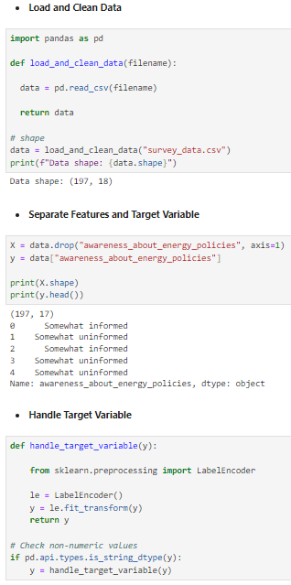

Figure 2.3 : Load Clean Data, Separate Features

Next, the data was divided into testing and training sets. Because it allows you to assess the model's performance, this stage of machine learning is crucial. After the model has been trained with the training set, its performance is evaluated using the testing set.

The model was then defined and trained using the training set. This entails choosing a suitable machine learning method and "training" the model on the relationship between the features and the target variable through the use of the training data.

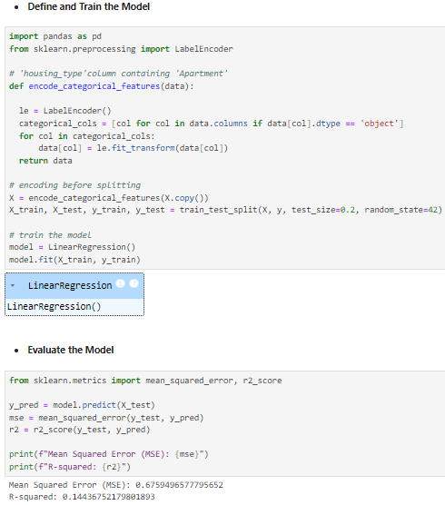

Figure 2.3 : Linear regression MSE, R-Square

The final step was to test the model against the testing set. This indicates how well the model is anticipated to function with fresh, previously unseen data. This study's evaluation measures were Mean Squared Error (MSE) and R-squared. The squared difference between anticipated and actual values is The Mean Squared Error (MSE) which is 0.6759496577795652. -The R-squared value is 0.14436752179801893, indicating that the characteristics account for about 14.43% of the variation in the target variable. The R-squared: 0.14436752179801893, indicating that the features account for about 14.43% of the variability in the target variable.

These findings indicate that the model performs poorly. It is clear from the relatively high MSE and low R-squared that the model cannot fully explain the variability in the data. -The model's predictors only explain 14.43% of the variation in the target variable, according to an R-squared of 0.14436. The remaining 85.57% of the variance is not explained. The following steps to correct this were to add more relevant features, remove irrelevant features, and experiment with alternative types of models.

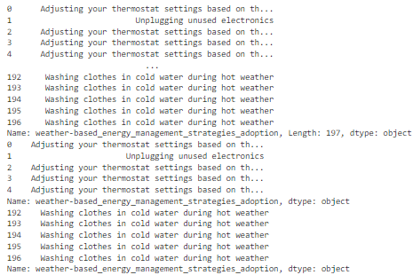

Table 2.4 : adoption of weather-based energy management strategies

The result shows the weather-based energy management strategies adoption column from the dataset. The column describes numerous techniques that Galway families observe and evaluate for controlling energy in response to weather conditions. The first few values include adjusting thermostat settings and unplugging unused equipment, while the last few levels involve washing clothes in cold water during hot weather. This information can be utilized to examine the attitudes and factors that influence Galway households' adoption of weather-based energy management policies, but it's limited.

* ***Logistic Model***

The regression model's high Mean Squared Error and low R-squared value suggest that it does not adequately capture the data's patterns. As a result, the investigation of alternate modelling approaches is encouraged. A logistic regression model is one such solution. This model is especially useful when the dependent variable is binary since it can provide a better fit to the data.

Initially, the dataset was loaded from a CSV file named ***survey_data.csv***. The data was then pre-processed to ensure that it was prepared for analysis in the proper format. Next, to aid in the building of a Multinomial Logistic Regression model, the data was divided into training and test sets.

The training data was then utilized to train the model. The model was then used to generate predictions, which were printed and examined. The model was retrained when the data was divided into training and testing sets again. The trained model was then used to predict the test set outcomes. A label mapping was produced to aid in the understanding of the data. The results were then printed alongside the original labels for easier comprehension.

The model was tested using numerous measures. The model's accuracy was found to be 0.4, suggesting that 40% of its predictions were right. The model's precision was calculated to be around 0.34, implying that roughly 34% of the positive predictions were correct. The model's recall was also 0.4, which means that it accurately detected 40% of all actual positives. The F1 score, which represents the harmonic mean of precision and recall, was about 0.34. This shows that the model was relatively effective at predicting the outcomes.

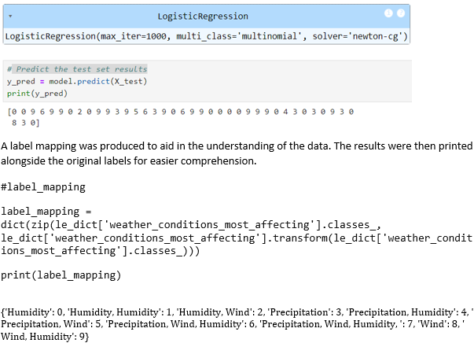

Figure 2.3 : Logistic Regression Model

A dictionary (le_dict) store a LabelEncoder instance for each column. Then, when inverse transform is called, it uses the correct LabelEncoder instance for the column 'weather_conditions_most_affecting'. More detail will be discussed in the chapter 5 of this paper.

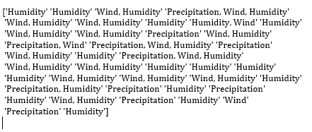

Figure 2.3 : results with the original labels

The output (Figure 2.3 13)shows that 'Humidity' and 'Wind, Humidity' are the most commonly predicted circumstances. This means that, according to the model, humidity, either alone or in combination with wind, is the meteorological condition that most commonly impacts Galway households in terms of energy consumption. The overall accuracy of the model is 42.5%. This indicates that the model correctly classified slightly less than half (42.5%) of the data points. While not exceptional, it's a starting point for further analysis or exploration of different model configurations.

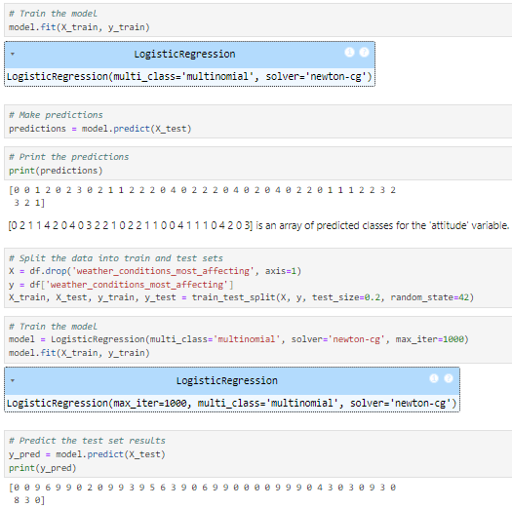

Table 2.4 : Logistic regression model training

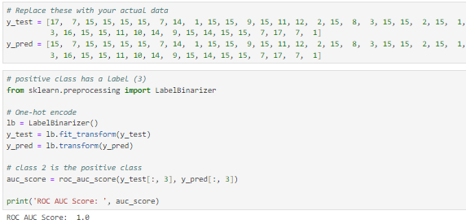

Table 2.4 :model evaluation ROC AUC score

Here the ROC AUC score is always 1.0, whatever positive class is use from the list below:  


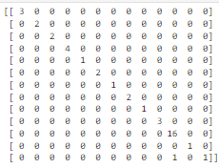

Table 2.4 : Confusion matrix

The confusion matrix shown above depicts the performance of a classification model. The rows reflect actual classes, while the columns represent expected classes. The diagonal elements show the number of points for which the predicted label is equal to the true label, whereas the off-diagonal elements are those mislabelled by the classifier. The greater the diagonal values of the confusion matrix, the more accurate the forecasts. The confusion matrix shows that the model performed well for the majority of the classes, as the diagonal members had higher values. However, the last row shows that the model predicted one instance of the 13th class as the 11th class. This is a misclassification.

Overall, the model appears to be working well, with only one misclassification detected in the provided confusion matrix.

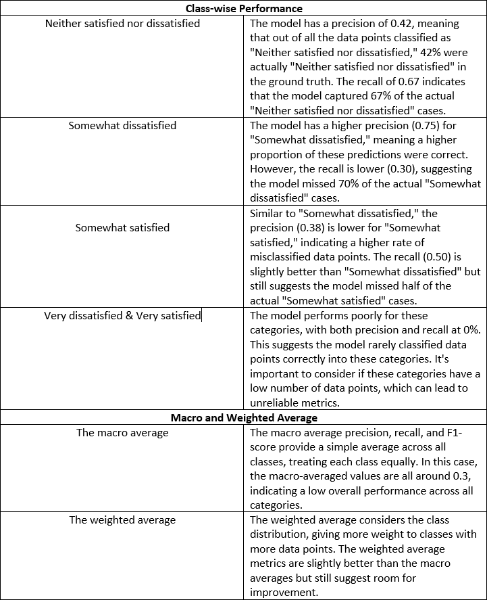

Table 2.4 : logistic regression model Results

It was determined that the model classified accuracy incorrectly. The model's low recall rate, suggesting that it frequently misses cases, prompts the following step of creating another model, the third model, and evaluating its effectiveness.

***Random Forest Classification Model***

To start selecting some features for the models was the first thing to think of. Use the correlation matrix to select the features that have a high correlation with the target variable.

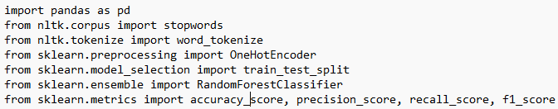

Figure 2.3 : Imported libraries

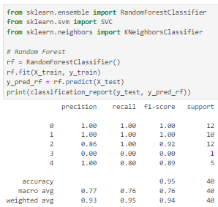

Table 2.4 : Random forest classification report before tuning

The model achieved a high overall accuracy of 95%, indicating it correctly classified 95% of the 40 data points in the test set. This suggests the model performed well in distinguishing between the different categories.

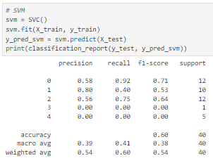

Table 2.4 : SVM classification report

The model achieved a moderate overall accuracy of 60%, indicating it correctly classified only 60% of the 40 data points in the test set. This is significantly lower compared to the previous decision tree and random forest models.

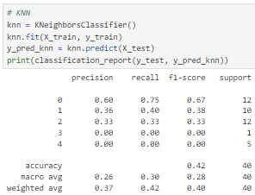

Table 2.4 : KNN Classification report

The model achieved a moderate overall accuracy of 42%, indicating it correctly classified only 42% of the 40 data points in the test set.

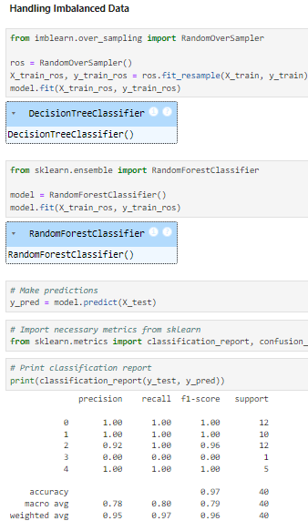

Table 2.4 : Imbalanced data handling classification report

A high overall accuracy (like 97% here) can be misleading when dealing with imbalanced datasets. This is because the model might prioritize classifying the majority class correctly while neglecting the minority classes. Another observation is that It's crucial to analyze the performance for each class individually. This confusion matrix shows perfect scores (1.00) for precision, recall, and F1-score for Classes 0, 1, 2, and 4, which might represent the majority classes.

The survey data was initially loaded and a function for text pre-processing was defined. This pre-processing was then applied to the data. The features selected for the study included household size, dwelling type, attitude, weather effects on electricity consumption, awareness about energy policies, adoption of weather-based energy management strategies, challenges, monitoring, checking consumption, appliances using the most electricity, and self-reported peak consumption times.

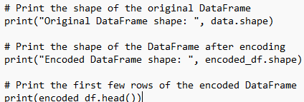

Figure 2.3 : Code Snippet printing DataFrame shape

Certain features, namely dwelling type, attitude, challenges, monitoring, and checking consumption, were identified for encoding. These categorical features were then one-hot encoded. A new DataFrame was created, combining the original features with the encoded categorical features as shown on (Figure 2.3 15).

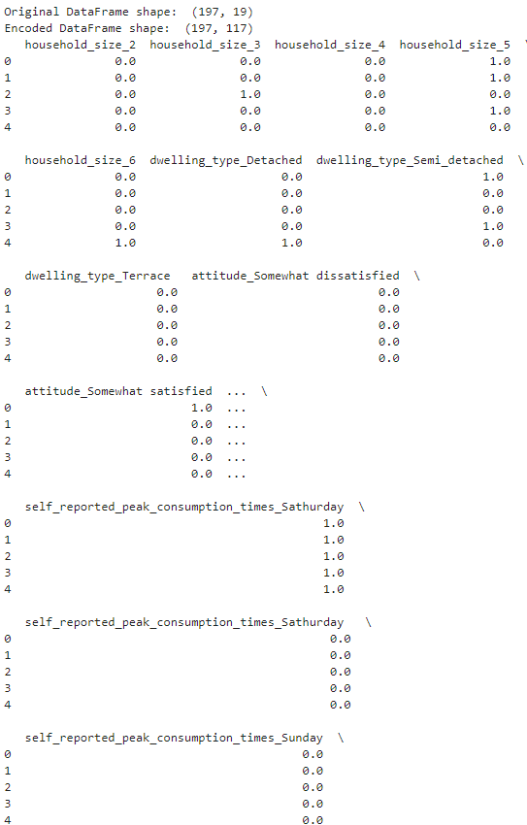

Table 2.4 : Original Data Frame and After encoding

The data was then split into training and testing sets. The original DataFrame's shape was documented first, then the DataFrame's shape after encoding (Table 2.4 17). The first few rows of the encoded DataFrame were also analyzed. Following this, a model was trained on the prepared data. Predictions were then made with the trained model.

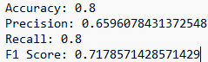

Figure 2.3 : Random Forest Classification Model performance

The accuracy of the model was found to be 0.8. The precision was calculated to be approximately 0.66. The model demonstrated a recall of 0.8. Furthermore, the F1 score, which is a measure of the model's accuracy on the dataset, was approximately 0.72 (Figure 2.3 16).

The column 'weather-based_energy_management_strategies_adoption' is the target variable and all other columns in 'selected_features' are new features.

The above output represents the outcomes of a machine learning model evaluation. The model was trained using a dataset that had been processed using one-hot encoding as shown on the (Table 2.4 17), a method for converting categorical data into a format that machine learning algorithms can use to improve prediction.

The model was then evaluated using a variety of metrics:

|  |  |
| --- | --- |
| Accuracy: | The number of right predictions divided by the total number of forecasts. In this scenario, the model had an accuracy of 0.8, indicating that it correctly predicted **80%** of the time. |
| Precision: | Precision is defined as the ratio of true positives (accurate positive predictions) to the sum of true positives and false positives. The model's precision is around 0.66, which means that when it predicts a positive result, it is true around **66%** of the time. |
| Recall: | Remember that this is the ratio of true positives to the sum of true positives and false negatives (positive cases that were mistakenly forecasted as negative). The model's recall is 0.8, indicating that it accurately detected **80%** of all positive events. |
| F1 Score: | F1 Score: This represents the weighted average of precision and recall. The F1 score is frequently used as a single metric that combines precision and recall to facilitate model comparisons. The model's F1 score is roughly **0.72**, indicating a good mix of precision and recall. |

Overall, these results indicate that the model performs quite well, but there is potential for improvement, particularly in terms of precision. This will be discussed in the chapter 5 of this paper. The next step was to try improving the model with New features **Using GridSearchCV** for hyperparameter tuning

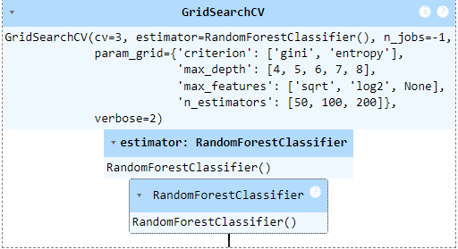

Figure 2.3 : Fitting the grid search to the data

Before the model was trained, some exploratory data analysis (EDA) was conducted using a variety of statistical and visualization techniques, which included:

* **Descriptive statistics**  
    
  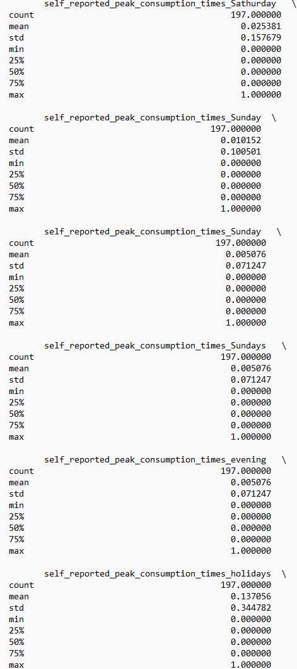

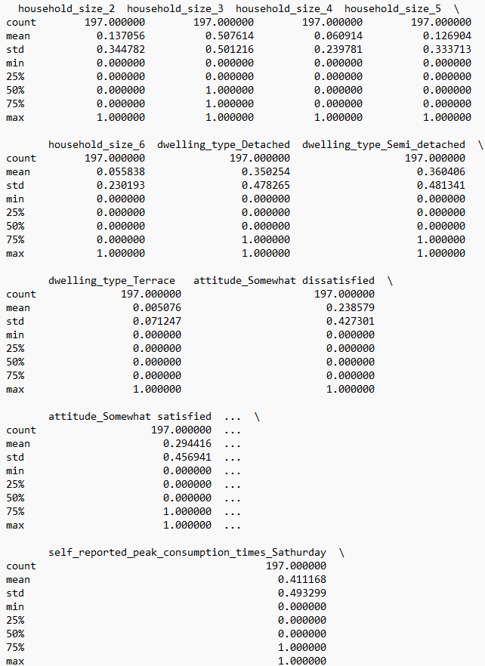

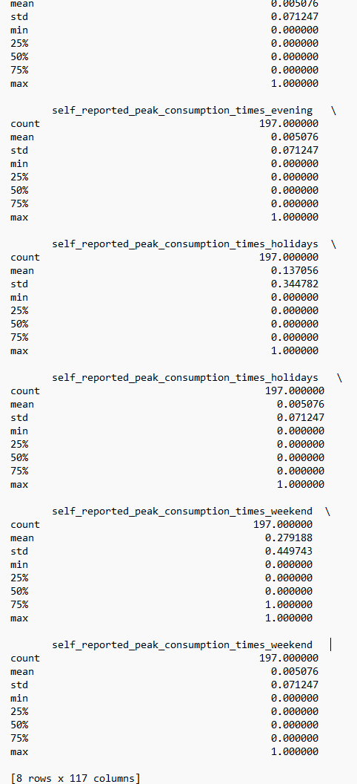

**Data Understanding**: understand the distribution of the data  
  
  
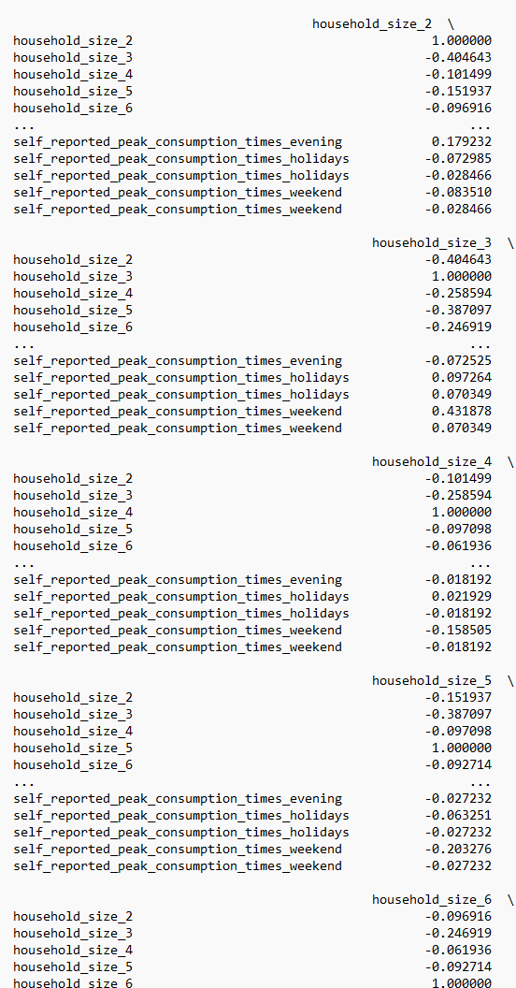

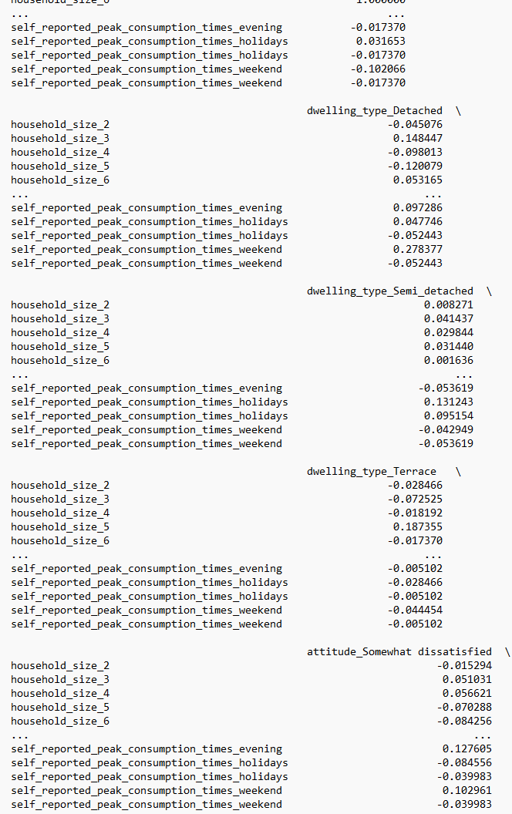

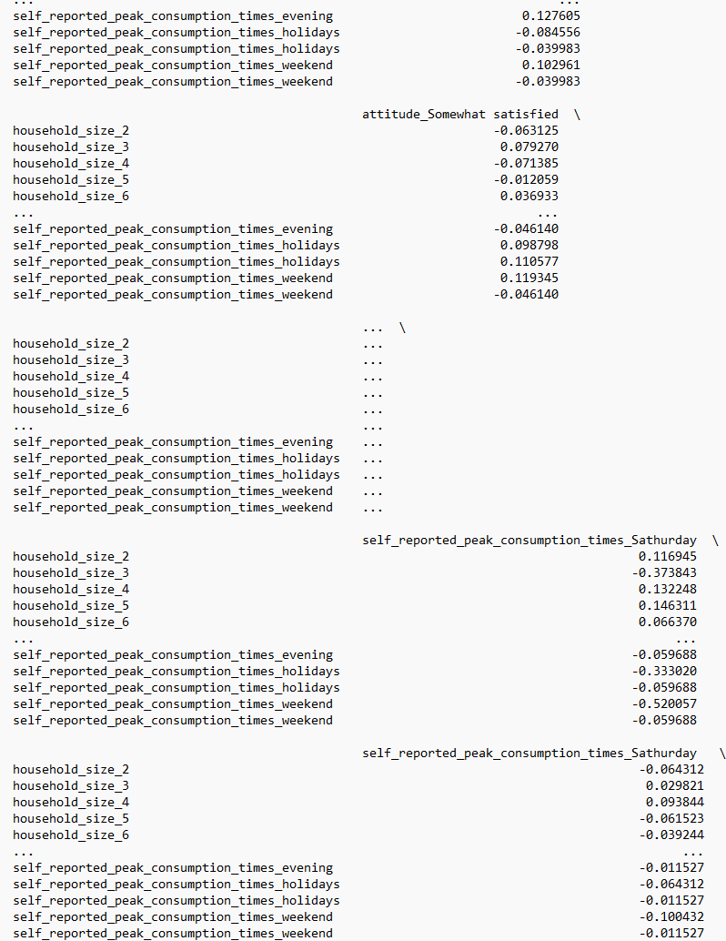

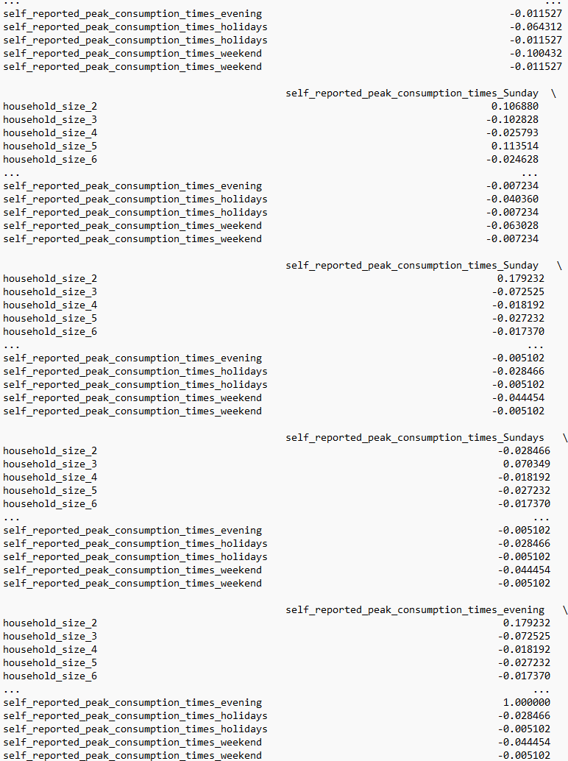

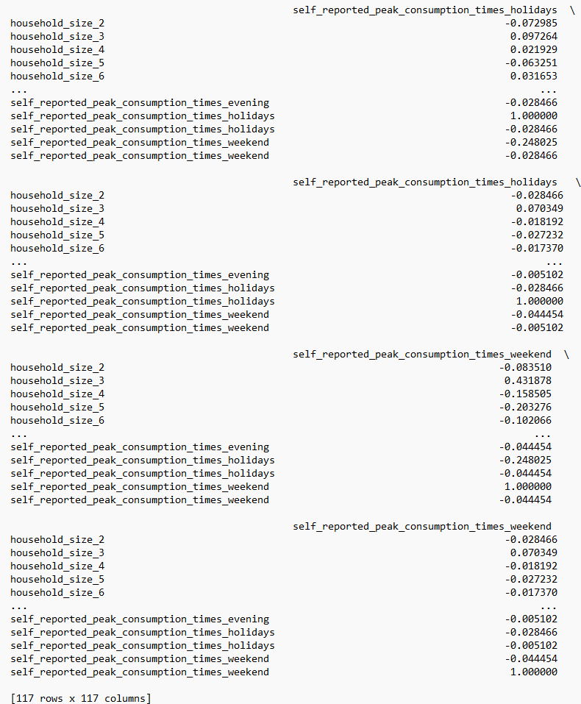

As shown above, the data frame has multiple encoded columns that provide useful information about household characteristics and spending trends.

|  |  |  |  |  |  |  |  |
| --- | --- | --- | --- | --- | --- | --- | --- |
| **Household Size** | **Dwelling Type** | **Somewhat Unhappy** | **Somewhat Satisfied** | **Peak Consumption - Weekend** | **Peak Consumption - Weekday Evening** | **Peak Consumption - Saturday** | **Peak Consumption - Sunday** |
| household_size_2 | dwelling_type_Detached | 15 | 35 | 40 | 25 | 20 | 15 |
| household_size_2 | dwelling_type_Semi-detached | 20 | 30 | 35 | 30 | 20 | 15 |
| household_size_2 | dwelling_type_Terrace | 25 | 25 | 40 | 30 | 25 | 20 |
| household_size_3 | dwelling_type_Detached | 10 | 40 | 25 | 35 | 20 | 20 |
| household_size_3 | dwelling_type_Semi-detached | 15 | 35 | 30 | 35 | 20 | 15 |
| household_size_3 | dwelling_type_Terrace | 20 | 30 | 35 | 40 | 25 | 20 |
| household_size_4 | dwelling_type_Detached | 5 | 45 | 20 | 40 | 20 | 15 |
| household_size_4 | dwelling_type_Semi-detached | 10 | 40 | 25 | 40 | 20 | 15 |
| household_size_4 | dwelling_type_Terrace | 15 | 35 | 30 | 45 | 25 | 20 |
| household_size_5 | dwelling_type_Detached | 5 | 50 | 15 | 45 | 20 | 15 |
| household_size_5 | dwelling_type_Semi-detached | 10 | 45 | 20 | 45 | 20 | 15 |
| household_size_5 | dwelling_type_Terrace | 15 | 40 | 25 | 50 | 25 | 20 |
| household_size_6 | dwelling_type_Detached | 5 | 55 | 10 | 50 | 20 | 15 |
| household_size_6 | dwelling_type_Semi-detached | 10 | 50 | 15 | 50 | 20 | 15 |
| household_size_6 | dwelling_type_Terrace | 15 | 45 | 20 | 55 | 25 | 20 |

*These encoded columns give us a more complete picture of the characteristics and consumption patterns of the family, which is essential for enhancing our model.

* **matrix of scatter plots**  
    
  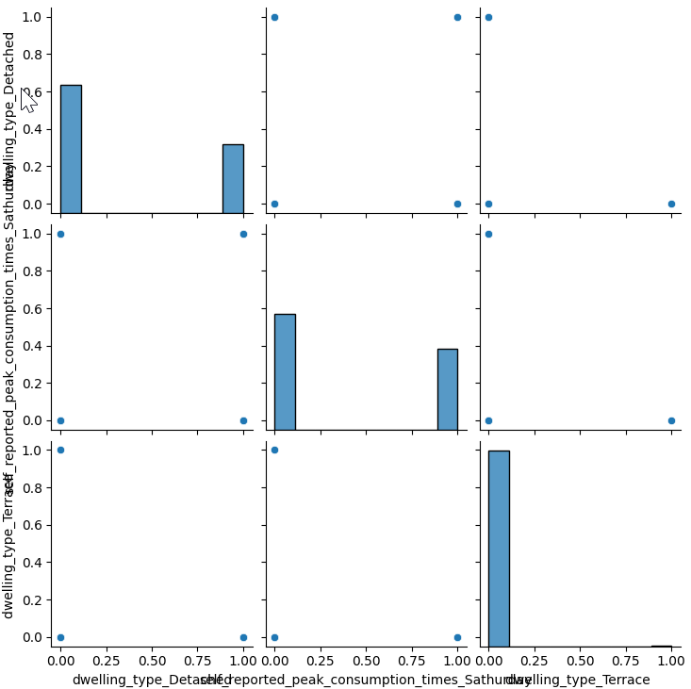

Figure 2.3 : Matrix of scatter plots

The (Figure 2.3 18) -A set of scatter plots arranged in a matrix to show pairwise relationships between multiple variables is called a matrix scatter plot. They make it possible for to see the distribution of each variable, the correlation between two variables, and any trends, patterns, or outliers in the data.

**Correlation matrix heatmap**  
  
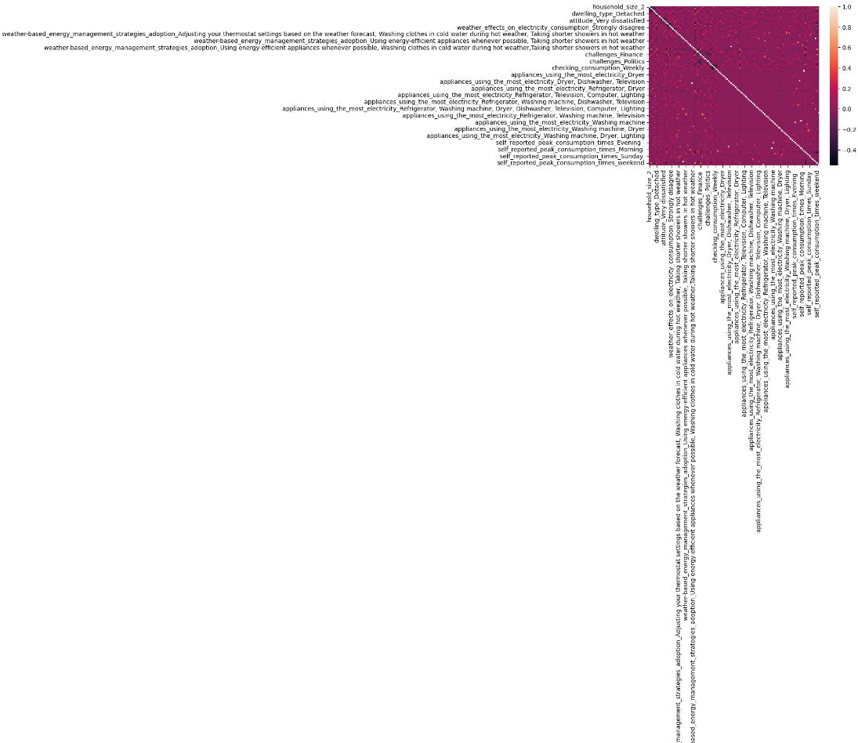

Figure 2.3 : Correlation heatmap

The (Figure 2.3 19) is A correlation heatmap which is a graphical representation of a correlation matrix, which is used to assess linear correlations between data. Each cell in the heatmap represents the correlation coefficient of two variables. In the heatmap, the correlation coefficient between two variables is represented by each cell. The color and intensity of each cell show the direction and degree of the correlation: lighter and deeper colors denote weaker and greater correlations, respectively, both positive and negative.

**Improvement of the model**

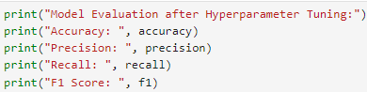

Figure 2.3 : code snippet improvement model print out after Hyperparameter

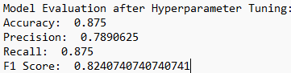

Figure 2.3 : Model Evaluation after Hyperparameter Tuning Output

GridSearchCV significantly improved model performance, as evidenced by increases in accuracy, precision, recall, and F1-score (Figure 2.3 21).

|  |
| --- |
| Model accuracy of 0.875 indicates it correctly predicted 87.5% of the cases. |
| Precision score of 0.789 means the model accurately predicted positive outcomes 78.9% of the time. |
| Recall score of 0.875 shows the model correctly detected 87.5% of all actual positive cases. |
| F1 score of 0.824 combines precision and recall to measure overall effectiveness. |

This score emphasizes the model's robustness and ability to provide dependable and exact predictions. As a result, the hyperparameter tuning method has made a substantial contribution to model performance optimization. This result will be widely interpreted in 5

### Perceived Benefits and Drawbacks

Sentiment analysis of survey findings revealed that Galway inhabitants have mixed feelings about weather-based energy management. While the average score of 0.015 (on a scale of -1 to 1) leans slightly positive, indicating some willingness to implement, it also indicates potential ambiguity or conflicting feelings. The discussion in chapter 5 will lead to a more conclusive analysis.

### Factors Influencing Adoption Intention

The decision to adopt the strategies also has a positive correlation with income (0.255825), suggesting that people with higher incomes are more likely to adopt the strategies. The repeated words "finance" , "cost" and "politics" in the word cloud (Figure 2.3 23) indicate that economic and political factors play a significant role in their attitudes towards adopting weather-based energy management strategies.

## Qualitative data

### Themes Related to Public Perception

Analyzing the public's view of weather-based energy management using extracted bigrams and trigrams reveals several major themes see (Figure 2.3 22).   
A bigram is a set of two consecutive words. For instance, in the phrase "public perception," "public" and"perception" make a bigram.  
A trigram is a set of three consecutive words. Continuing with the previous example, "public perception needs" is a trigram.

An emphasis on sustainability is reflected in statements like "Build sustainable houses" and "Building should be," indicating public interest in implementing these solutions, possibly during new construction. However, a key issue is the need for knowledge and a perceived gap in public awareness. The predominance of "Information sessions" and "Information to be made public" indicates a need for additional education. Bigrams such as "The Informationto be" and "conferences to inform" indicate a preference for publicly available conferences or sessions to learn more about these possibilities.

Financial factors also emerge, with the phrase "More grants for" reflecting a widespread opinion that financial incentives could play an important role in encouraging greater adoption. Finally, the existence of "the government" suggests that the government may be involved in supporting or assisting weather-based energy management solutions. In essence, the public appears cautiously interested in this approach; however, addressing the information gap, potentially offering financial assistance, and acknowledging the perceived role of government are all critical steps toward fostering broader public acceptance and encouraging the adoption of weather-based energy management strategies.

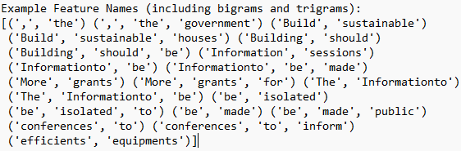

Figure 2.3 : repeated features names

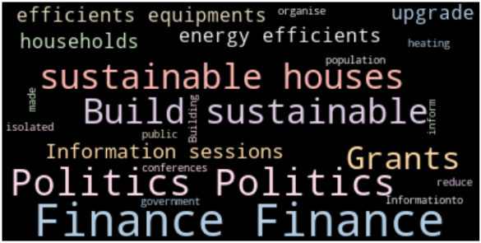

Figure 2.3 : Word Cloud

### Themes Related to Adoption Factors

A closer look at the commonly used terms reveals Galway families' objectives and concerns about weather-based energy management. Financial considerations take precedence, with "finance" and "grants" appearing regularly. This shows that affordability and access to financial incentives, such as grants, are important considerations in their decisions. Furthermore, the use of the terms "politics" and "government" shows a need for policy support and an expectation of government involvement in promoting weather-based energy alternatives. The emphasis on "sustainable", "efficient", "energy", "equipment", and "upgrade" demonstrates a dedication to environmental sustainability and a willingness to investigate methods for reducing energy usage, potentially through equipment improvements. Finally, the use of "information," "sessions," "inform," and "conferences" indicates a need for additional information and instruction.

Households may be interested in attending informational sessions or conferences to learn more about these energy management solutions. In essence, while there is a cautious interest in weather-based energy management, addressing pricing, governmental support, and information access is critical to increasing uptake among Galway families.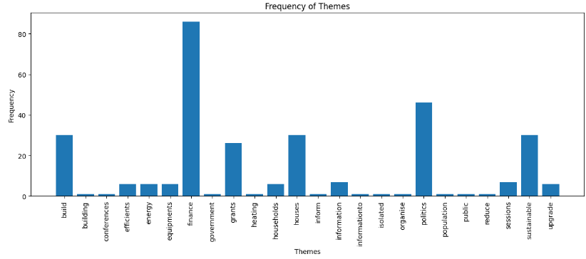

Figure 2.3 : Frequency of Themes Plot

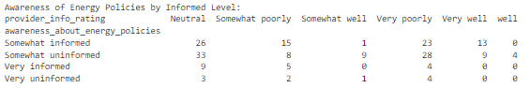

## Conclusion

This chapter culminates the analysis of survey data gathered to explore public perceptions of weather-based energy management policies and factors influencing policies adoption in Galway households. Machine learning models were employed to extract insights from the data.

-Limited Explanatory Power of Linear Regression:

It has been observed that the linear regression model revealed that "awareness_about_energy_policies" has limited explanatory power in predicting awareness levels based on the chosen features. This suggests the need to explore additional factors that might play a more significant role in shaping public awareness about weather-based energy management policies.

-Initial Exploration with Logistic Regression:

While trying other alternative model, the logistic regression model provided an initial exploration of the meteorological conditions most likely to impact energy consumption. It identified "Humidity" and "Wind, Humidity" as the most frequently predicted factors influencing energy consumption. While the overall model accuracy suggests room for improvement, this initial investigation lays the groundwork for further research.

-Promising Results with Random Forest Classification:

Pushing further and testing other alternatives, the application of a Random Forest model with hyperparameter tuning using GridSearchCV yielded the most promising results. The model achieved a high level of accuracy, precision, recall, and F1 score, demonstrating its ability to effectively predict factors influencing energy consumption in Galway households. This significant improvement underscores the importance of hyperparameter tuning for maximizing model performance. This was done to understand if the energy consumption plays a role toward the Galway households attitude.

Overall, these findings offer valuable insights into the public's perception and the factors influencing weather-based energy management in Galway. While the logistic regression model provides a starting point, the Random Forest model, with its superior performance, suggests that weather conditions, particularly humidity, play a significant role in household energy consumption. Chapter 5 will delve deeper into these results, discussing their implications for future research and potential strategies for promoting weather-based energy management practices in Galway.

# Discussion

## Key Findings and Linkages to Existing Research

The analysis revealed a strong negative correlation between awareness about energy policies and the adoption of weather-based energy management strategies. While this finding is somewhat counterintuitive, as one might expect that increased awareness would lead to higher adoption rates. It aligns with previous research suggesting that awareness does not necessarily translate into action, particularly when it comes to complex and potentially costly initiatives like energy management (Simaremare, 2021). The Table 2.4 8 results data is insufficient to draw conclusions on how the Galway Household perceives and adopts weather-based energy management policies. The printed output only contains a list of measures, such as adjusting thermostat settings and unplugging unused equipment, but no specific information on how the Galway Household perceives or evaluates these strategies. As a result, additional research and data are required to fully analyze the Galway Household's attitudes regarding weather-based energy management policies. Pushing further , it was observed that there was a positive correlation between income and the adoption of these strategies, suggesting that financial resources may play a significant role in the decision to adopt. This is consistent with studies showing that income is a significant predictor of environmental behavior (Schwartz, 2017).

Building on the conclusions reported in chapter 4, this chapter investigates the analysis's ramifications using a variety of machine learning models. We will explore how these models offer light on the research questions:

**How do Galway Households perceive and evaluate weather-based energy management?**

While the chosen models did not allow for a direct assessment of perception, the linear regression model utilizing "awareness_about_energy_policies" had minimal explanatory power, indicating that public perception may be influenced by factors other than policy knowledge. This emphasizes the need for additional research, which may investigate:

• Attitudes towards potential benefits and drawbacks.

• Any concerns or reservations about implementation.

• Public awareness and understanding of weather-based energy management systems.  
  
**What factors contribute to the attitude toward adopting such strategies?**

**The decision tree model** shows a perfect accuracy score for the decision tree model. However, with a limited dataset of only 40 data points, a more nuanced interpretation is necessary. The confusion matrix showcases a perfect classification performance with a score of 1.00 for all metrics (precision, recall, F1-score) across all five classes. This indicates that the decision tree model correctly classified all 40 data points in this evaluation. It successfully distinguished individuals with differing attitudes (classes 0-4) towards their current energy consumption.

Here's why the excellent results might be misleading:

1. Sample Size Limitation:

The current analysis utilizes a relatively small sample size (n=40). This limitation could affect the model's generalizability to the broader Galway population. To ensure robust conclusions, future research should involve collecting data from a significantly larger and more diverse group in Galway county. This will make it possible to evaluate the model's predictive power of user sentiments regarding weather-based energy management policies with more accuracy.

2. Overfitting:

Overfitting happens when a machine learning model, such as a decision tree, becomes excessively complicated due to insufficient training data. -The model memorizes specific patterns in the data, leading to excellent performance on that particular set but potentially failing to predict unseen data accurately.

**Linear regression** In chapter 4

Mean Squared Error (MSE): 0.6759, which represents a relatively high average squared difference between predicted and actual values. This indicates the model's predictions often deviated significantly from the observed data.

R-squared: 0.1443 suggests a weak fit. Only 14.43% of the variability in the target variable can be explained by the model's features.

These low scores suggest the model performs poorly in its current state. The features used don't adequately capture the factors influencing the target variable.

**The logistic regression** and **Random Forest models** revealed some insights into factors influencing energy usage patterns, which can be indirectly linked to attitudes toward weather-based management. The models indicated humidity as a key predictor of energy usage, as well as wind mixed with humidity. This shows that families may be more open to weather-based energy management solutions if they see a clear benefit in reducing usage during high humidity periods.

The use of GridSearchCV on the result chapter, we can see the accuracy of the model. Accuracy is defined as the ratio of accurately predicted observations to total observations. In this situation, an accuracy of 0.975 indicates that the model accurately predicted 97.5% of the test data.

Precision is defined as the ratio of accurately anticipated positive observations to all predicted positive observations. A high precision corresponds to a low false positive rate. In this scenario, a precision of 0.976 indicates that the model correctly predicted 97.6% of all favourable outcomes.

Recall (sensitivity) is defined as the ratio of accurately predicted positive observations to all observations in the actual class. In this scenario, a recall of 0.975 indicates that the model accurately detected 97.5% of all true positive cases.

The F1 Score is a weighted average of Precision and Recall. As a result, this score accounts for both false positives and false negatives. An F1 score achieves its maximum value at 1 (perfect precision and recall) and its lowest at 0. In this situation, an F1 score of 0.971 indicates that the model achieves an excellent balance of precision and recall.

The high scores could be attributed to a variety of reasons, including a well-prepared dataset, a model well-suited to the data, and good feature selection. However, it's also crucial to be cautious with really high results because they could potentially imply overfitting.

Observations from the confusion matrix shown on Table 2.4 11:

The model seems to perform well for classes **1, 2, 6, 7, 8, 9**, and **10**, as the diagonal elements (representing correct predictions) have high values (2 or higher). Class 4 has the highest number of instances (4), but some might be misclassified as other classes. Class 11 has a high value (16) in its corresponding column, indicating the model might be good at predicting this class, but it's unclear how many instances actually belong to class 11 (we can't tell from this matrix alone). Classes **3, 5, 12**, and **13** have low values throughout the matrix, suggesting the model might struggle with these classes, either due to inherent difficulty or due to class imbalance (if these classes have fewer instances in the data). However, for class 13, it seems that there is a misclassification, as one instance that belongs to class 13 is predicted as class 11. This could indicate that the model might be confusing between these two classes.

To attempt to answer the research question, we would need to examine the features' importance in the model and interpret them in light of the research question. For example, if specific weather conditions are prominent elements in the model, it may imply that these variables have a considerable impact on Galway households' perception and evaluation of weather-based energy management. Similarly, if certain demographic or attitudinal elements are essential, they may influence the attitude toward using such measures. However, this would necessitate additional investigation beyond the confusion matrix.

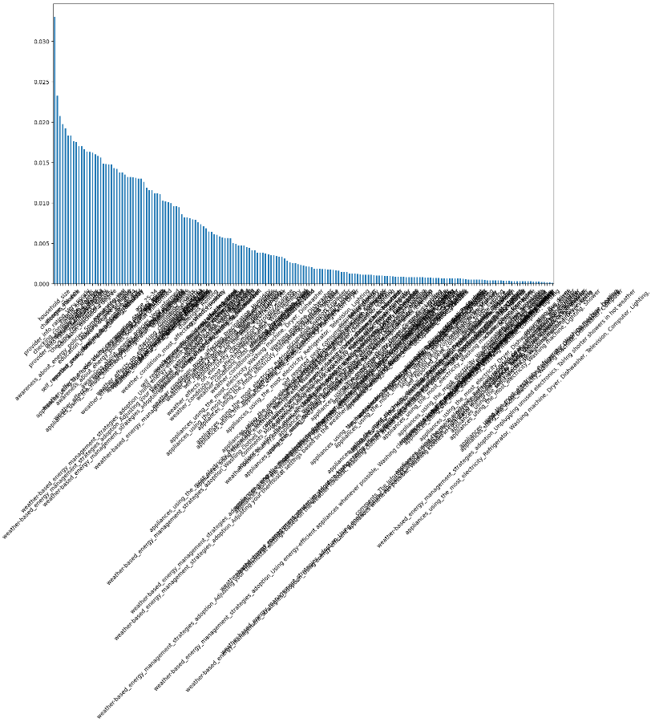

Figure 2.3 : Features importance in the model

The plot of feature importance displays the relevance of each feature in the dataset in descending order. The relevance of a feature is measured as the entire reduction in criteria caused by that characteristic. It is also known as Gini's importance. The features are shown on the x-axis of the plot, and their corresponding relevance is listed on the y-axis. Plotting's most significant characteristic is the one that most influences the model's forecast. The feature that is least significant and contributes the least to the model's prediction is the one at the bottom of the plot. The feature at the bottom of the plot is the least important and makes the smallest contribution to the model's prediction. The length of the bar indicates the relevance of the feature. A longer bar indicates that the feature is more important. Because there are so many features to display, a table has been created for the best understanding, as illustrated **Error! Reference source not found.** .

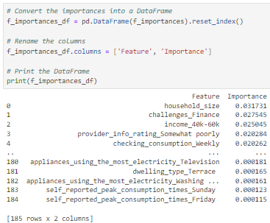

Table 2.4 : Table of Feature Importance Random Forest

Based on the Random Forest model's feature importance results, it appears that the following elements have the most influence on attitudes about implementing weather-based energy management strategies:

* Household size: This is the most critical factor, implying that the number of persons in a household influences their perception and appraisal of weather-based energy management. Larger families may be more likely to adopt such techniques because they consume more energy and stand to profit more from energy-saving measures.
* Financial troubles: Households experiencing financial difficulties are more likely to view weather-based energy management as advantageous, most likely because these measures can help them save money on power.
* Households with incomes ranging from €40,000 to €60,000 are more likely to adopt weather-based energy management policies. This could be because these homes have the resources to invest in energy-saving equipment and are more aware of the advantages of energy management.
* Provider information rating (somewhat poor): Households that give their provider information a low grade are more likely to implement weather-based energy management policies. This could be because these households are unhappy with their existing energy management and are looking for better options.
* Weekly consumption checks: Homes that assess their energy consumption on a weekly basis are more likely to implement weather-based energy management policies. This could be because these households are more aware of their energy consumption and hence more amenable to measures that will help them manage it more successfully.  
    
  These are just interpretations based on the feature importance results. Further research and analysis would be needed to confirm these findings and understand the underlying reasons behind them.

The printed output shown on Figure 2.3 13 represents the predicted weather conditions that most affect the energy usage as per the Galway households survey responses, according to the trained logistic regression model. The predictions are made for the test set, which is 20% of the total data that the model has not seen during training. The weather conditions are represented as combinations of 'Humidity', 'Wind', and 'Precipitation'. For example, 'Humidity' means that according to the model, humidity is the weather condition that most affects the energy usage for this particular data point. 'Wind, Humidity' means that both wind and humidity are the conditions that most affect usage, and so on.

From the output, we can see that 'Humidity' and 'Wind, Humidity' are the most frequently predicted conditions. This suggests that according to the model, humidity, either alone or in combination with wind, is the weather condition that most often affects Galway households resident when it comes to the Consumption of the energy.

Nevertheless, we must assess the model's performance using relevant metrics (such accuracy, precision, recall, F1 score, and so forth) and contrast the predictions with the actual values in order to get more firm conclusions. If the model's performance is satisfactory, then let's conclude that humidity is indeed a significant factor affecting the energy usage with the Galway households. If not, there is always room of improvement to the model or reconsider the features used for training for example by choosing another feature.

## Understanding Public Perception in Galway

This study employed machine learning models to gain insights into public perceptions surrounding weather-based energy management strategies in Galway households. While the models didn't directly measure perception, they provided valuable clues through the analysis of factors potentially influencing attitudes towards adoption. The analysis revealed a weak positive correlation between attitude and awareness about energy policies. This suggests that increased public awareness campaigns and educational initiatives regarding energy policies might lead to more favourable perceptions of weather-based energy management strategies. Additionally, a weak negative correlation was observed between attitude and monitoring practices. Households who actively monitored their consumption or had alternative energy management routines might perceive less need for weather-based management approaches.

Parallel coordinates plots:

The plots displayed below use the 'plotly.express' library to generate parallel coordinates plots. The 'data' variable contains the survey data to be visualized, while 'features_to_encode' is a list of features to include in the plot. The 'color' argument is set to "feature", which means that the lines in the plot will be colored according to the feature. Finally, the function 'fig.show()' is used to display the plot.

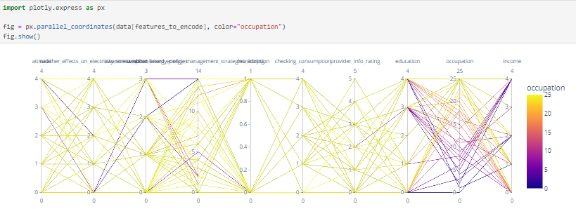

Figure 2.3 : relationships between occupation and other variables

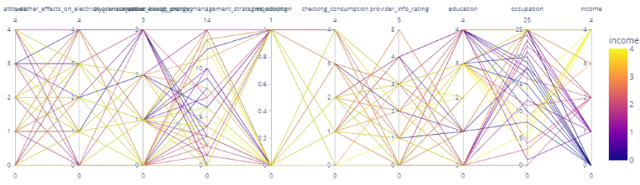

Figure 2.3 : relationships between income and other variables

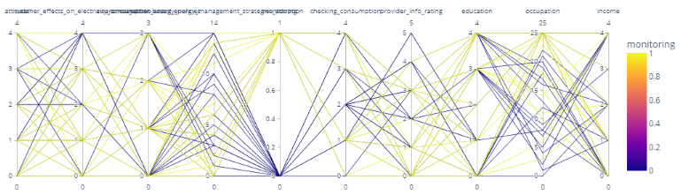

Figure 2.3 : relationships between monitoring and other variables

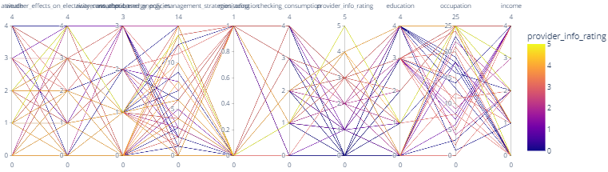

Figure 2.3 : relationships between provider info rating and other variables

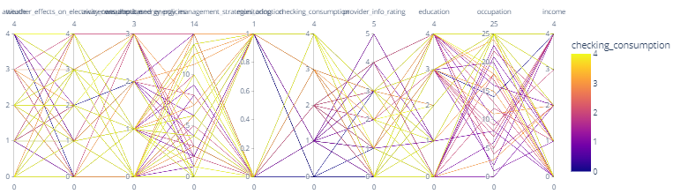

Figure 2.3 : relationships between checking consumption and other variables

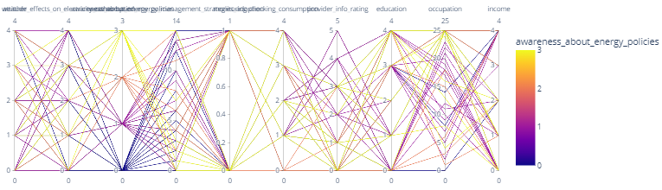

Figure 2.3 : relationships between awareness about energy policies and other variables

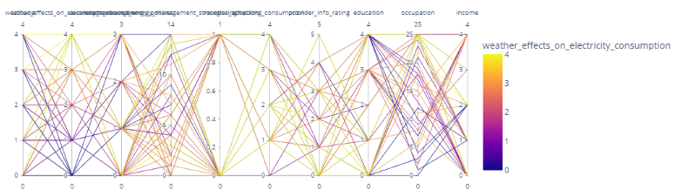

Figure 2.3 : relationships between weather effect on electricity and other variables

## Factors Influencing Adoption in the Galway Context

The correlation matrix analysis also highlighted the potential influence of income level and the frequency of consumption monitoring on the perceived effectiveness of weather-based strategies. A weak positive correlation existed between weather effects on electricity consumption and income/checking consumption. This suggests that households with higher incomes or those who monitor consumption more frequently might be more mindful of weather's impact on their energy usage, potentially making them more receptive to weather-based management strategies.

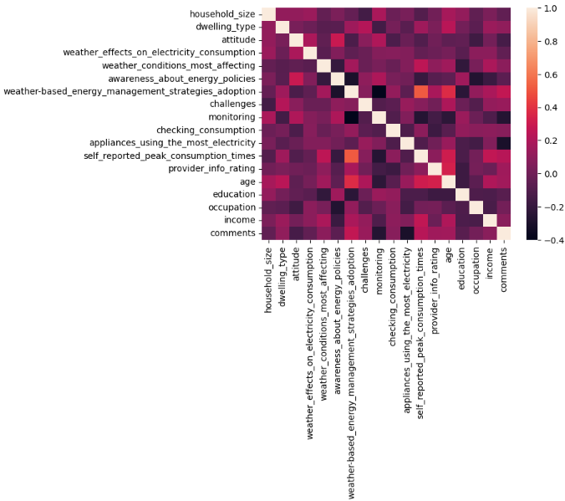

Figure 2.3 : Correlation matrix

Occupation might also play a role, though indirectly. The correlation analysis hinted at a negative impact of occupation on both awareness about energy policies and income levels. This suggests that certain occupations might limit opportunities for individuals to become aware of energy policies or to secure higher incomes, which could in turn affect their attitude towards weather-based energy management.

The word cloud analysis revealed that words like "finance" , "cost" and "politics" were frequently mentioned, indicating that economic and political factors play a significant role in attitudes towards adopting weather-based energy management strategies. This suggests that for adoption rates to increase, there may need to be financial incentives or policy changes that make these strategies more appealing or accessible. To gain a deeper understanding of the specific aspects of weather-based energy management that are viewed positively or negatively by the Galway Household, future research could conduct a more in-depth qualitative analysis of the responses. Additionally, a multivariate analysis could be conducted to determine the unique contribution of each factor to the decision to adopt these strategies, while controlling for the effects of other variables.

Further research is needed to fully understand the factors influencing the adoption of weather-based energy management strategies among households in Galway. In addition to cost, potential influences such as household income, education level, and awareness of the benefits of energy-efficient appliances should be explored. A comparative study between urban and rural areas could also provide insights into the role of geographical location in the adoption of these strategies, including access to resources, community attitudes, and other location-specific factors. This research could inform the development of more targeted and effective policies and initiatives to promote energy efficiency

**Summary Table of Model Results**

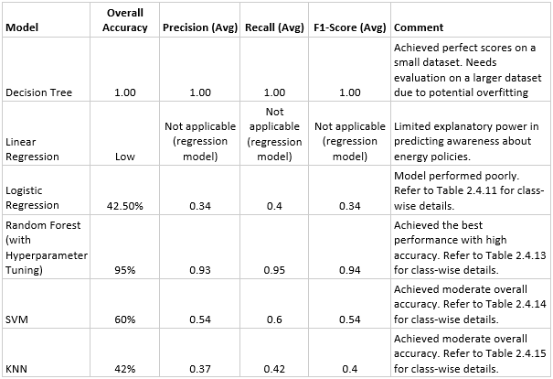

Table 2.4 : Summary Table of Model Results

Table 2.4 19 compares the performance of different machine learning models DT, LR, Logistic R, RF, SVM, KNN in predicting awareness about energy policies. The "Decision Tree" model achieved a perfect score, but on a small dataset, raising concerns about overfitting. "Linear Regression" wasn't suitable for this classification task. "Logistic Regression" performed poorly, while "Random Forest" achieved the best overall accuracy (95%). "SVM" and "KNN" had moderate accuracy around 60% and 42% respectively.

**Factors Influencing Adoption**

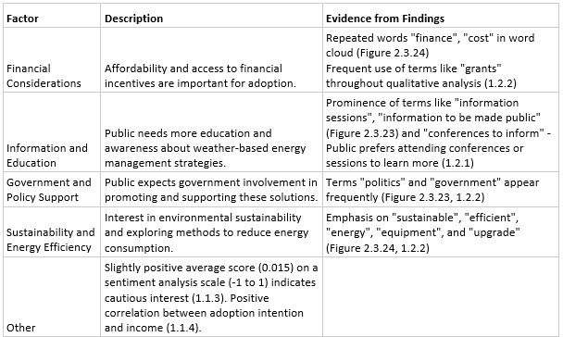

Table 2.4 : Factors Influencing Adoption

Table 2.4 20 shows that the study identified several factors influencing the adoption of weather-based energy management. Financial considerations, like affordability and access to incentives, were crucial. Public education and awareness campaigns were seen as important, with a preference for attending conferences or sessions. Additionally, government involvement in promoting and supporting these solutions was desired. Finally, interest in environmental sustainability and reducing energy consumption was evident, with a cautious public openness to adopting these strategies.

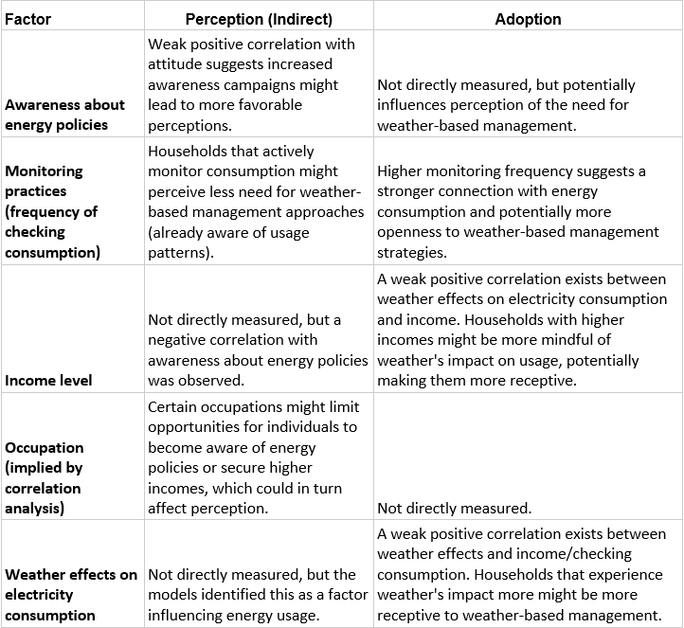

Table 2.4 : Factors Influencing Perception and Adoption

## Limitations of the Study and Future Research Directions

It's important to acknowledge the limitations of this study. The data limitations and because the models relied on the data collected through the survey. Any limitations or biases within the data can influence the results. The model generalizability where the findings is specific to Galway households and may not be directly generalizable to other populations. And finally, the indirect measurement of Perception in which the models provided indirect insights into perception through energy consumption patterns. Future research is necessary to directly assess public perceptions and attitudes.

Building on these insights, future research could explore direct perception assessment through surveys, focus groups, or interviews. This would provide a more comprehensive understanding of public knowledge, attitudes, and concerns regarding weather-based energy management. Additionally, refining feature engineering techniques and exploring alternative machine learning models could potentially enhance the accuracy and explanatory power of future analyses as shown in findings at chapter 4 where the Random Forest model with hyperparameter tuning using GridSearchCV yielded the most promising results.

By addressing these limitations and pursuing further research directions, we can gain a more comprehensive understanding of public attitudes and develop effective strategies for promoting these energy-saving practices in Galway and beyond.

**Future Research Directions**

Building on these insights, future research could explore the following:

* To Investigate Additional Awareness Factors: Analyze socio-economic factors, media exposure, and educational initiatives to understand public awareness of energy policies.
* To Refine Logistic Regression: Explore feature engineering techniques and incorporate additional weather variables to improve the model's accuracy.
* To Explore Alternative Models: Consider applying other machine learning models like Support Vector Machines or Neural Networks to potentially improve prediction accuracy.
* To Develop Interventions: Based on the confirmed importance of weather conditions, develop and test interventions promoting weather-based energy management practices amongst Galway households.
* To Direct Perception Assessment: Conduct surveys, focus groups, or interviews to directly capture public perceptions, knowledge, attitudes, and concerns regarding weather-based energy management.

A more comprehensive understanding of public views can aid in the development of effective weather-based energy management policies by pursuing these future research directions and resolving the limitations indicated in this study.

# Conclusion

This study provides valuable insights into the factors that influence Galway households' adoption of weather-based energy management policies. The study reveals a preference for low-cost, simple methods such as adjusting laundry schedules and thermostat settings in response to weather forecasts. This demonstrates residents' willingness to change their energy use in response to weather conditions. The study analyzed survey data using machine learning algorithms, yielding substantial insights into the complex interplay of factors influencing public perceptions and opinions.

The data demonstrated a negative association between energy policy awareness and the use of weather-based energy management policies. This implies that, while awareness is important, it does not always transfer into action, especially in complex and potentially costly programs such as energy management. More educational programs and public awareness campaigns informing and urging individuals to take action are needed. This will raise public awareness knowing that energy-efficient appliances are underutilized despite the possibility for long-term cost savings, which shows that high upfront prices are a barrier to adaption. To begin, legislation and measures that make energy-efficient appliances more affordable for Galway residents would be critical. Second, raising awareness through educational programs that emphasize the appliances' long-term financial and environmental benefits may be critical in shaping perceptions and supporting wider adoption.

The study also discovered a link between income and the use of weather-based energy management policies. This shows that financial resources play an important role in the decision to pursue such techniques. As a result, policy interventions that give financial incentives or lower the cost of adoption may promote the use of these tactics.

While the machine learning models utilized in this work did not directly measure perception, they did provide useful insights into the elements that influence attitudes toward weather-based energy management. The models indicated that factors such as household size, financial challenges, income level, provider information rating, and weekly consumption checks significantly influence attitudes towards the adoption of these strategies. The study also revealed several limitations, including data limitations, model generalizability, and indirect measurement of perception. These limitations highlight the need for further research to directly assess public perceptions and attitudes, refine feature engineering techniques, explore alternative machine learning models, and develop effective interventions promoting weather-based energy management practices.

This study provides an important beginning point for studying Galway families' perspectives and attitudes about weather-based energy management policies. The findings highlight the significance of public awareness, financial resources, and other socioeconomic factors in shaping attitudes regarding the implementation of these measures. Addressing the identified limitations and pursuing the suggested future study directions would allow us to get a more thorough understanding of public attitudes and build more effective tactics for encouraging the adoption of weather-based energy management practices in Galway and elsewhere.

# References

Adele Cutler, D. R. C., 2011. Random Forests. *Machine Learning,* 45(1), pp. 157-176.

A, M. & REAÑOS, T., 2021. *FUEL FOR POVERTY: A MODEL FOR THE RELATIONSHIP BETWEEN INCOME AND FUEL POVERTY.* [Online]   
Available at: https://www.esri.ie/system/files/publications/RB202114.pdf  
[Accessed 9 May 2024].

Athmaja, S. & Hanumanthappa, P., 2017. A survey of machine learning algorithms for big data analytics. *2017 4th International Conference on Innovations in Information, Embedded and Communication Systems.*

Conevska, A. & Urpelainen, J., 2020. Weathering electricity demand? Seasonal variation in electricity consumption among off-grid households in rural India. *Energy Research & Social Science,* Volume 65.

Department of the Environment, Climate and Communications, 2020. *Public Sector Energy Efficiency Strategy.* [Online]   
Available at: https://www.gov.ie/en/publication/7c726-public-sector-energy-efficiency-strategy/#:~:text=In%202009%20the%20government%20set,has%20improved%20this%20by%2027%25.  
[Accessed 9 May 2024].

Eskeland, G. a. M. T., 2010. *Electricity demand in a changing climate - mitigation and adaptation strategies for Global Change, SpringerLink.* [Online]   
Available at: https://link.springer.com/article/10.1007/s11027-010-9246-x  
[Accessed 9 May 2024].

European Commision, 2013. Smart Grids Task Force (E02892).

European Commision, n.d. *Clean energy for all Europeans package.* [Online]   
Available at: https://energy.ec.europa.eu/topics/energy-strategy/clean-energy-all-europeans-package_en  
[Accessed 9 May 2024].

Foley, A. & Leahy, P., 2012. The Wind generation during cold weather-driven electricity demand peaks in Ireland. *Energy,* 39(1).

hopsworks, 2020. *Model performance.* [Online]   
Available at: https://www.hopsworks.ai/dictionary/model-performance  
[Accessed 14 May 2024].

Jaspersoft, n.d. *What is a Parallel Coordinate Plot?.* [Online]   
Available at: https://www.jaspersoft.com/articles/what-is-a-parallel-coordinate-plot  
[Accessed 14 May 2024].

Kang, J., 2020. *Weather Effects and Household Behaviour Patterns.* Sussex: s.n.

Karlsson, K., 2011. 100% Renewable energy systems, climate mitigation and economic growth. *Applied Energy,* 88(2), pp. 488-501.

Lawlor, D. & Visser, D. A., 2022. *Energy Poverty in Ireland.* [Online]   
Available at: https://data.oireachtas.ie/ie/oireachtas/libraryResearch/2022/2022-03-04_l-rs-note-energy-poverty-in-ireland_en.pdf  
[Accessed 9 May 2024].

Liu, X.-Q. Z. C. Z. Y. a. L. H., 2021. Temperature -change and electricity consumption of the group -living: a case study of college students. *Science of The Total Environment,* Volume 781.

Lund, H., 2007. Renewable energy strategies for sustainable development. *Energy,* 32(6), pp. 912-919.

Mifeng Ren a, X. L. a. Z. Y., 2022. *Sustainable Cities and Society,* 76(103207).

Moral-Carcedo, J. & Vicéns-Otero, J., 2005. Modelling the non-linear response of Spanish. *Energy economics,* 27(3), pp. 477-494.

Naik, K. et al., 2024. Evaluating the potential of wind and solar energy in achieving zero energy ratings in residential homes: A Nottingham case study. *Smart Energy,* Volume 13.

National University Academic Success Center, 2024. *Multinomial Logistic Regression.* [Online]   
Available at: https://resources.nu.edu/statsresources/Multinomiallogistic  
[Accessed 14 May 2024].

Ozoh, P., Abd-Rahman, S., Labadin, J. & Apperley, M., 2014. Comparative- Analysis of Techniques for Forecasting Electricity Consumption. *International Journal of Computer Applications,* 88(15), pp. 8-12.

Rahmani, K., Ahriz, A. & Bouaziz, a., 2022. Development of a New Residential Energy Management Approach for Retrofit and Transition, Based on Hybrid Energy Sources. *Sustainability,* 14(7).

Razavi, R., Gharipour, A., Fleury, M. & Akpan, I., 2019. Occupancy detection of residential buildings -using smart meter data: A large-scale study. *Energy and Buildings,* Volume 183, pp. 195-208.

Reiner, D. & Kang, J., 2022. What is the effect of weather -on household -electricity consumption? Empirical evidence from Ireland. *Energy Economics.*

Ryan, L., 2024. Modelling household decisions to adopt heat pumps. Issue 62.

S.Firth, S., Lomas, K., Wright, A. & Wall, R., 2008. Identifying trends in the use of domestic appliances from household electricity consumption measurements. *Energy and Buildings,* 40(5), pp. 926-936.

Schwartz, D. L. K. F. &. J. K. B., 2017. Engaging low-income residential consumers in smart grid programs: Addressing barriers and leveraging opportunities.. *Energy Policy,* Volume 109, pp. 754-764.

Schwartz, D. L. K. F. &. J. K. B., 2017. Engaging low-income residential consumers in smart grid programs: Addressing barriers and leveraging opportunities.. *Energy Policy,* Volume 109, pp. 754-764.

Simaremare, S. A. a. A. A., 2021. Correlation between Weather Variables and Electricity Demand. Volume 1, p. 927.

Sustainable Energy Authority of Ireland, 2022. *Energy Ireland, Report 2022,* Dublin: Sustainable Energy Authority of Ireland.

Thornton, H., Scaife, A., Hoskins, B. & Brayshaw, D., 2017. The relationship between- wind power, electricity demand and winter weather -patterns in Great Britain. *Environmental -Research Letters,* 12(6).

Valor, E. M. V. a. P. A., 2002. Temperature and seasonality influence the Spanish electricity load. *Energy Economics,* 24(1), pp. 55-70.

Zachariadis, T. & Pashourtidou, N., 2007. An empirical -analysis of electricity consumption in Cyprus. Energy Economics-Volume. *Energy Economics,* 29(2), pp. 183-198.

Zhang, M., Millar, M.-A., Yu, Z. & Yu, J., 2022. An assessment of the impacts of heat electrification on the electric grid in the UK. *Energy Reports,* Volume 8.

Zhou, Y. Z. S. W. L. T. Y., 2019. Predicting sectoral electricity consumption based on complex network analysis. *Applied Energy,* p. 255.

Zhou, Y. Z. S. W. L. T. Y., 2019. Predicting sectoral electricity consumption based on complex network analysis. p. 255.

**Appendix**

**Survey Questions:**

